# **IDE & Tools**

1. **Visual Studio 2019 (Community version)**
2. **MSSQL Server (Express version)**
3. **SQL Server Management Studio (SSMS)**
4. **Source Tree**

# **Download Link:**

1. **Go to this link and download Visual Studio 2019 (Community version) :** [**https://visualstudio.microsoft.com/downloads/**](https://visualstudio.microsoft.com/downloads/)

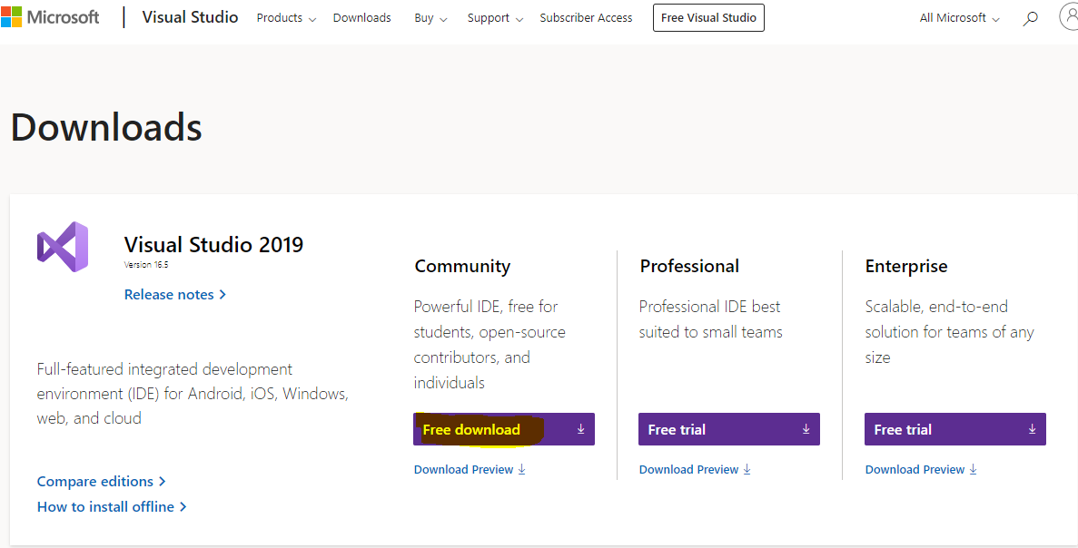

1. **Go to this link and download MSSQL Server (Express version)**

<https://www.microsoft.com/en-us/sql-server/sql-server-downloads>

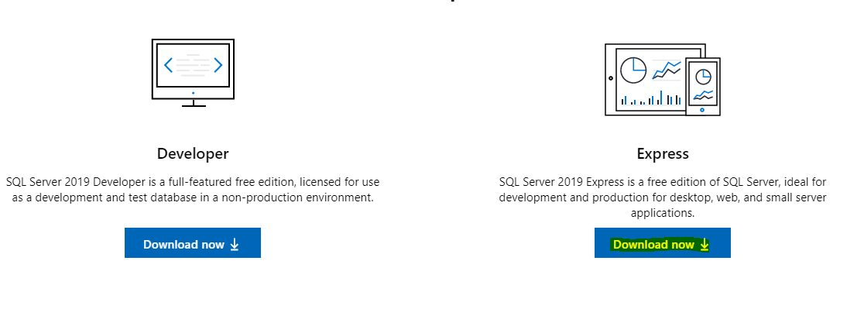

1. **Go to this link and Download SQL Server Management Studio (SSMS):** <https://docs.microsoft.com/en-us/sql/ssms/download-sql-server-management-studio-ssms?view=sql-server-ver15>

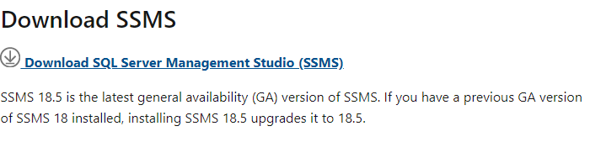

1. **Go to this link and Download SourceTree:** <https://www.sourcetreeapp.com/>

# **Installation Process:**

**Install Visual Studio 2019 (Community)**

**Step 1 - Make sure your computer is ready for Visual Studio**

Before you begin installing Visual Studio:

1. Check the system requirements. These requirements help you know whether your computer supports Visual Studio 2019.
2. Apply the latest Windows updates. These updates ensure that your computer has both the latest security updates and the required system components for Visual Studio.
3. Reboot. The reboot ensures that any pending installs or updates don't hinder the Visual Studio install.
4. Free up space. Remove unneeded files and applications from your %SystemDrive% by, for example, running the Disk Clean-up app.

**Step 2 - Download Visual Studio**

Next, download the Visual Studio bootstrapper file. To do so, choose the following button, choose the edition of Visual Studio that you want, choose Save, and then choose Open folder.

**Step 3 - Install the Visual Studio installer**

Run the bootstrapper file to install the Visual Studio Installer. This new lightweight installer includes everything you need to both install and customize Visual Studio.

1. From your Downloads folder, double-click the bootstrapper that matches or is like one of the following files:

vs_community.exe for Visual Studio Community

vs_professional.exe for Visual Studio Professional

vs_enterprise.exe for Visual Studio Enterprise

1. We'll ask you to acknowledge the Microsoft License Terms and the Microsoft Privacy Statement. Choose Continue.

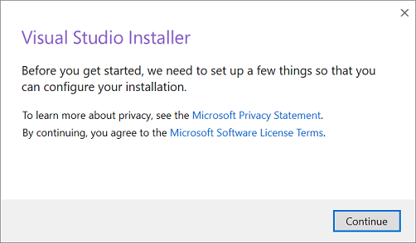

**Step 4 - Choose workloads**

After the installer is installed, you can use it to customize your installation by selecting the feature sets—or workloads—that you want. Here's how.

1. Find the workload you want in the Visual Studio Installer. After you choose the workload(s) you want, choose Install.

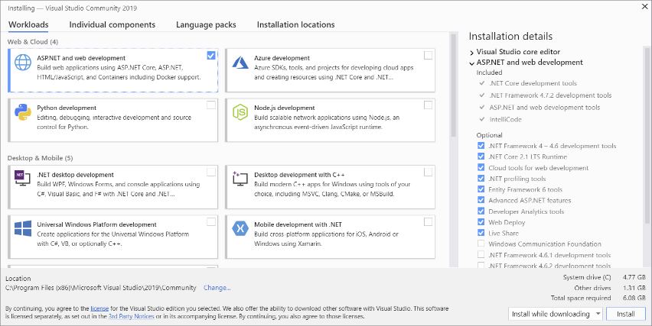

**Step 5 - Choose individual components (Optional)**

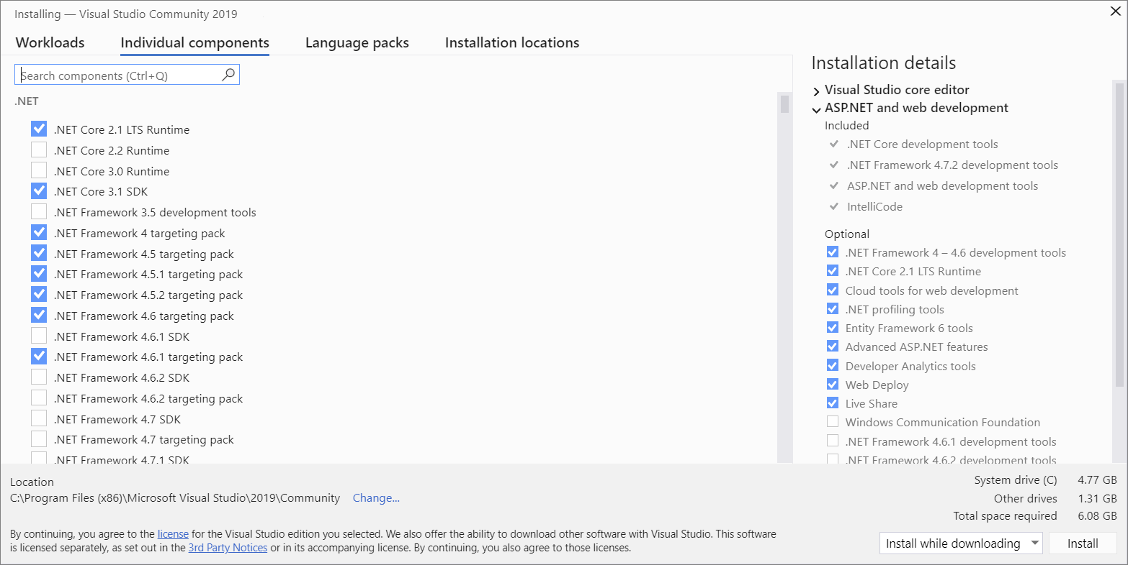

**Step 6 - Install language packs (Optional)**

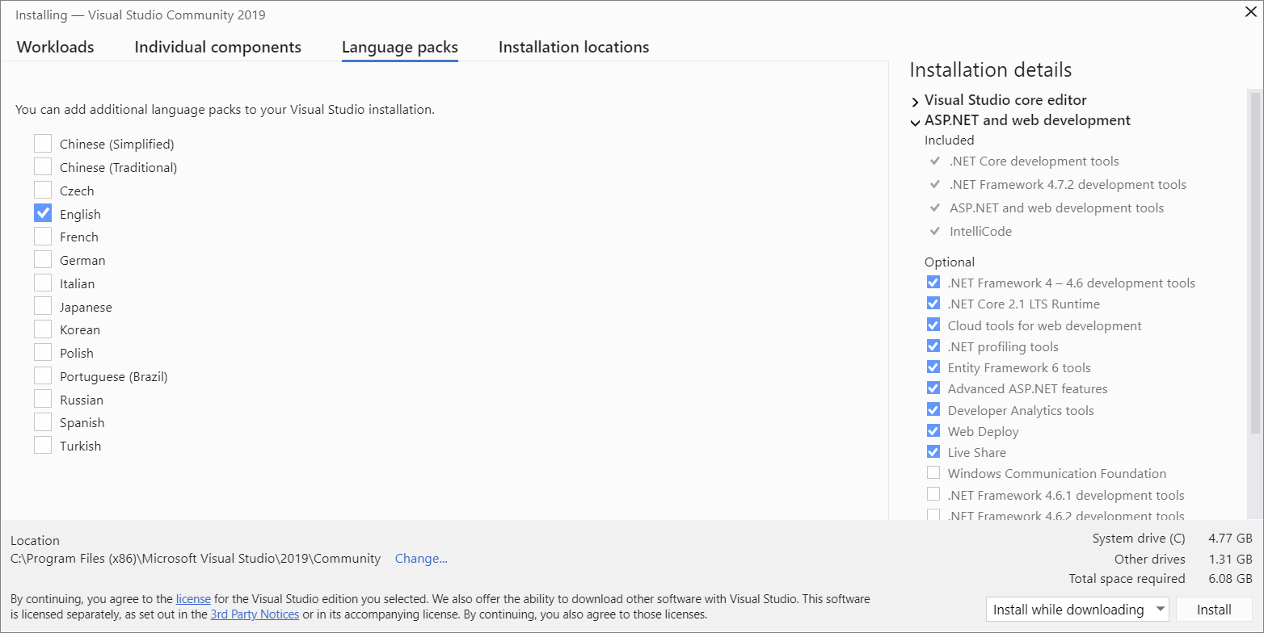

**Step 7 - Select the installation location (Optional)**

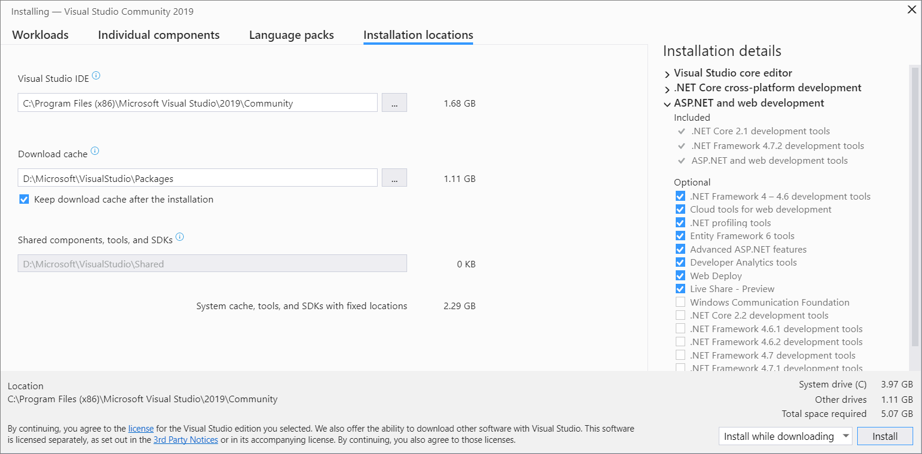

**Step 8 - Start developing**

After Visual Studio installation is complete, choose the Launch button to get started developing with Visual Studio.

**Install Microsoft SQL Server Express**

1. **Click installation file and select Custom installation, as this allows you to choose what you want to install from the extended tools.**

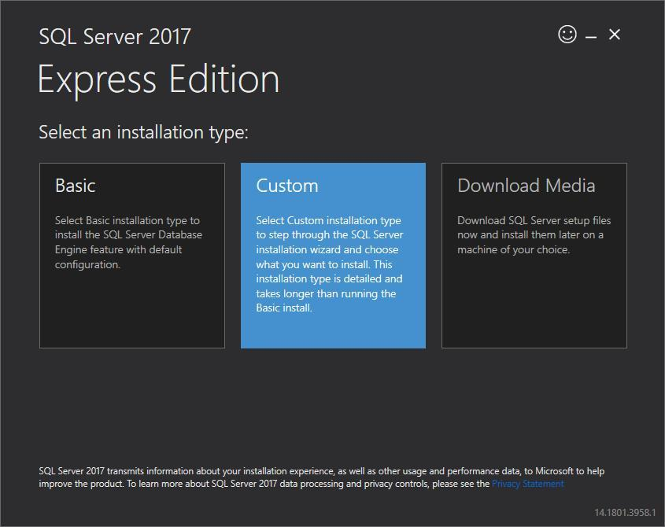

1. **On the next page, select a directory for the installation folder. You can leave tis as the default or select a custom installation directory.**

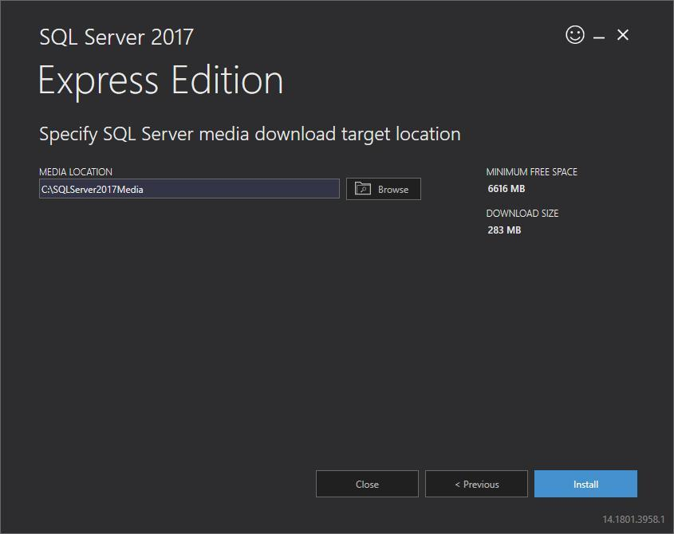

1. **Click the Install button to download the installation packages.**

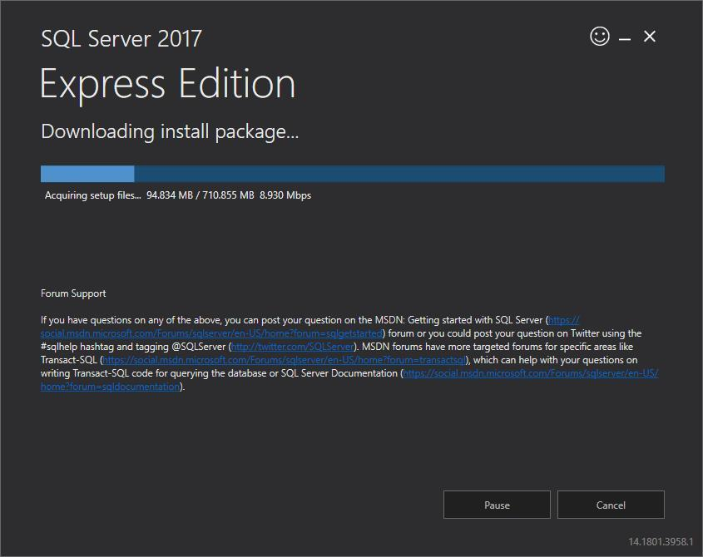

1. **After the installation package is downloaded, select New SQL Server stand-alone installation, as shown below**

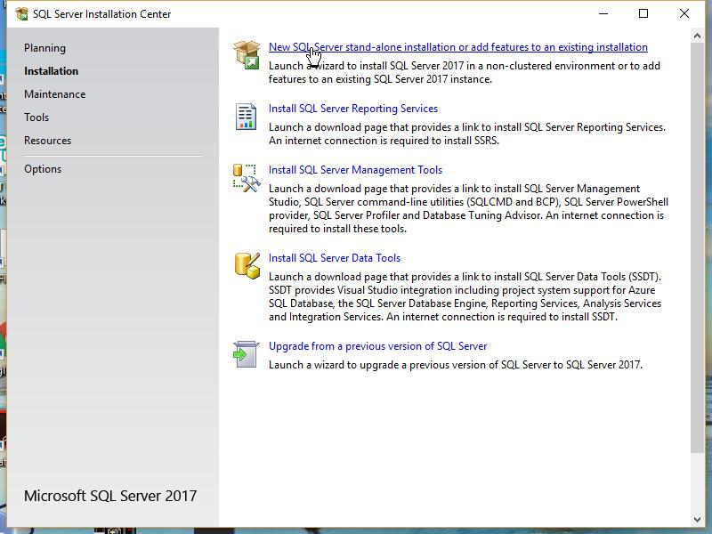

1. **On the next screen, you’ll see a setup process. Once it completes, click Next.**

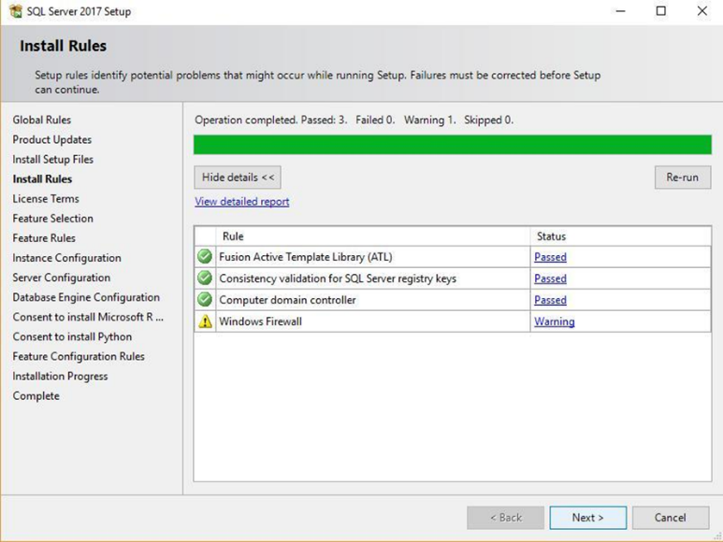

1. **You should now see the license terms. Review these if you’d like, and click Accept**

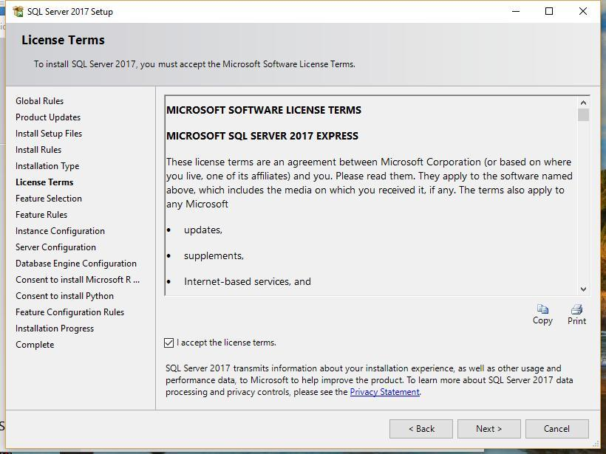

1. **You’ll then be taken to the Feature Selection screen, where you can choose custom SQL Server 2017 features you would like to install.**

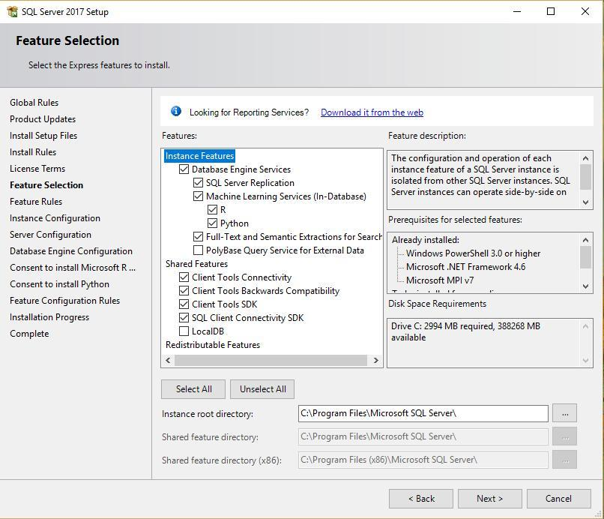

1. **Click the Next button. You can also go with the Default instance name.**

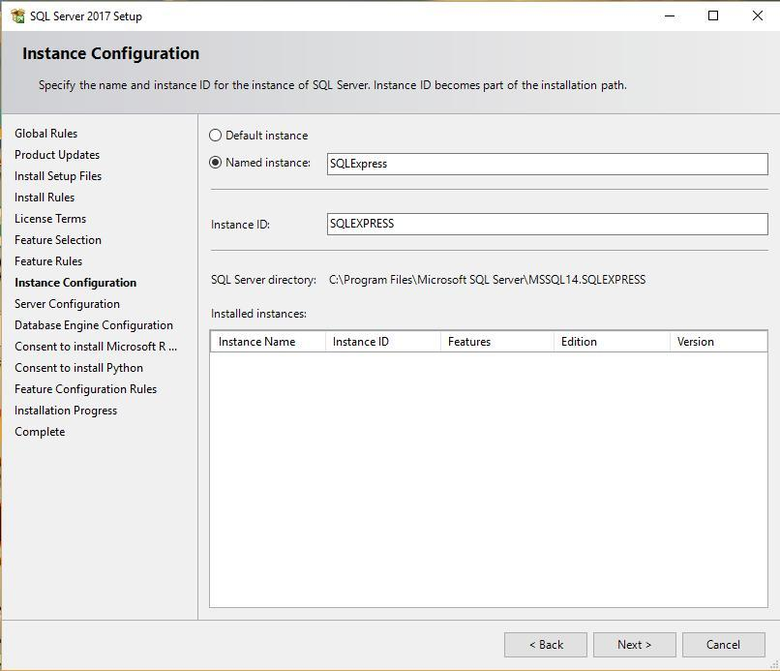

1. **Click Next. You’ll be taken to the Server Configuration screen. You can leave these settings untouched.**

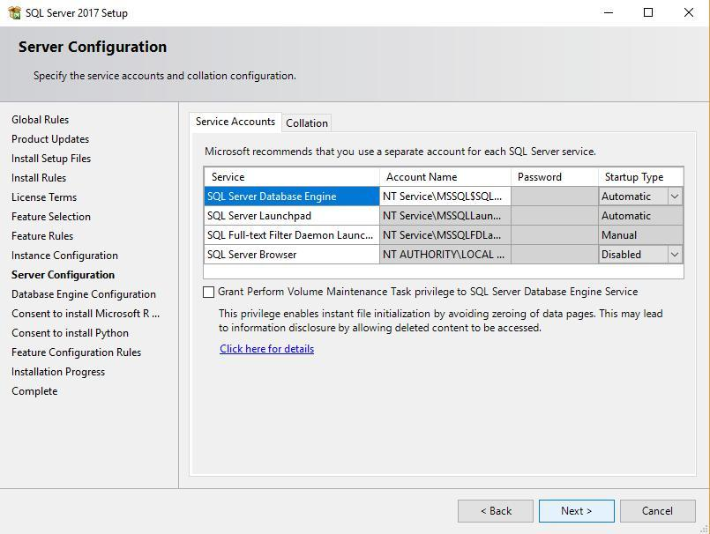

1. **Click Next. Select windows authentication mode and click next.**
2. **Click Next to see a summary of the installation process.**

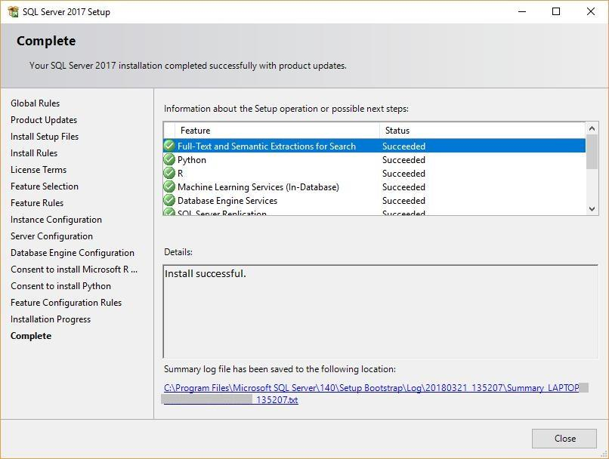

1. **Once the installation is complete, click Close to finish.**

**Install Microsoft SQL Server Management Studio**

1. **Simply run through the steps and click the Install button at the end.**

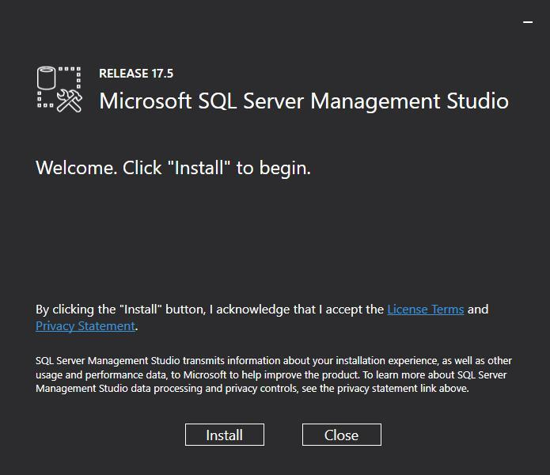

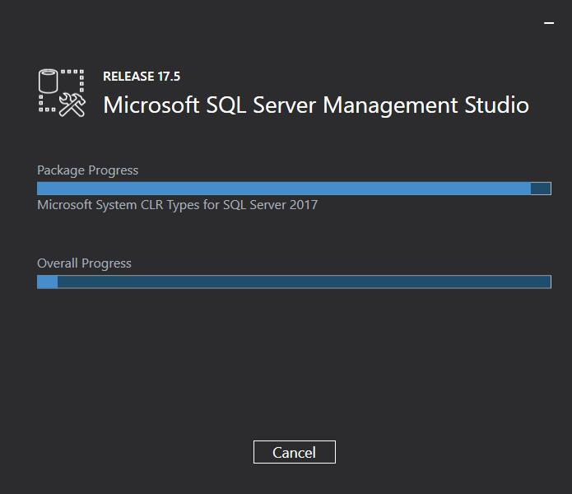

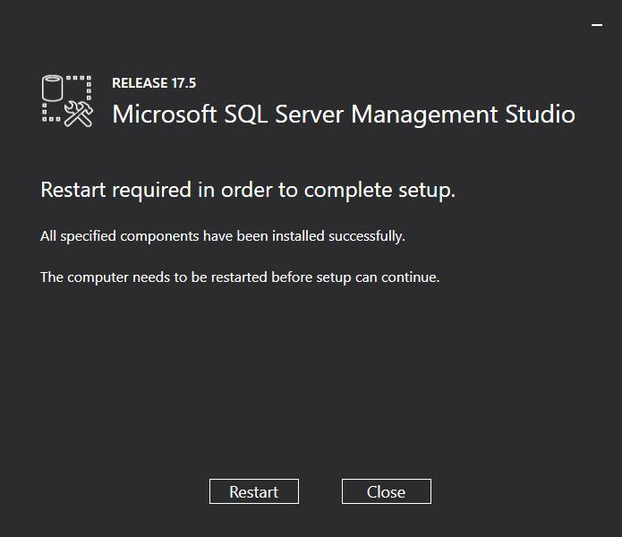

1. **After the installation, the SQL Server Management Studio is ready to launch:**

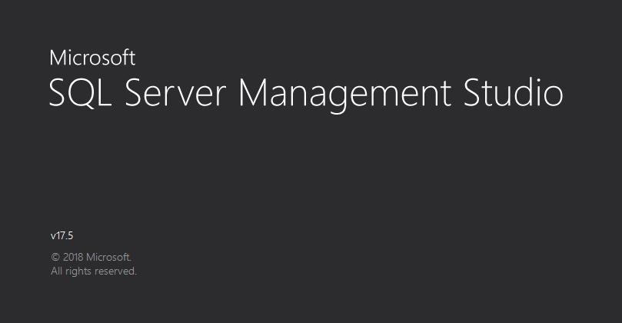

1. **First, you’ll see the Connect to Server window. Select the name of the server you’d like to connect to and enter the login and password for it. Click the Connect button.**

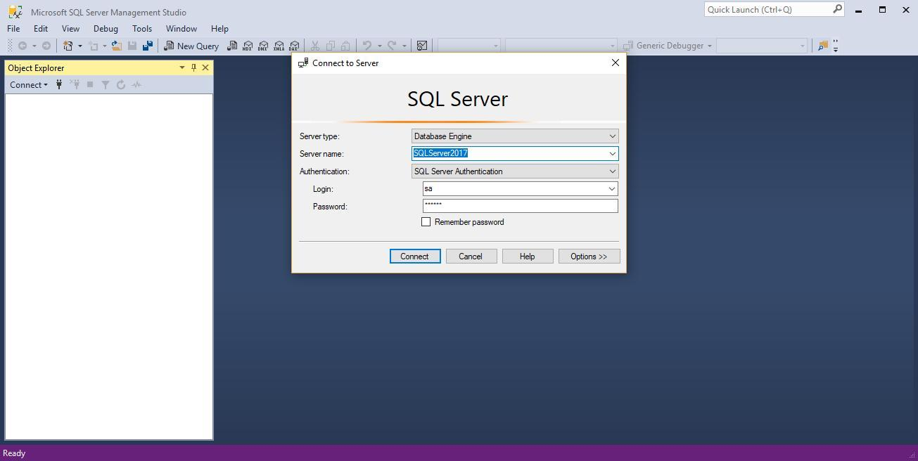

**Install SourceTree**

1. Go to the [Sourcetree website](https://www.sourcetreeapp.com/) and click the download button.
2. From the ZIP file you download, click the application file (EXE for Windows or DMG for Mac) to download.
3. After you install, you'll have to agree to the Atlassian Customer Agreement and hit **Continue**.
4. You need an Atlassian account to use Sourcetree. When you get to this screen, cick either **Use an existing account** or **Go to My Atlassian**and follow the prompts to [create a new account](https://id.atlassian.com/signup?application=mac&continue=https%3A%2F%2Fmy.atlassian.com%2Fproducts%2Findex). Once you've got an account, you'll be able to log in with **Use an existing account**.

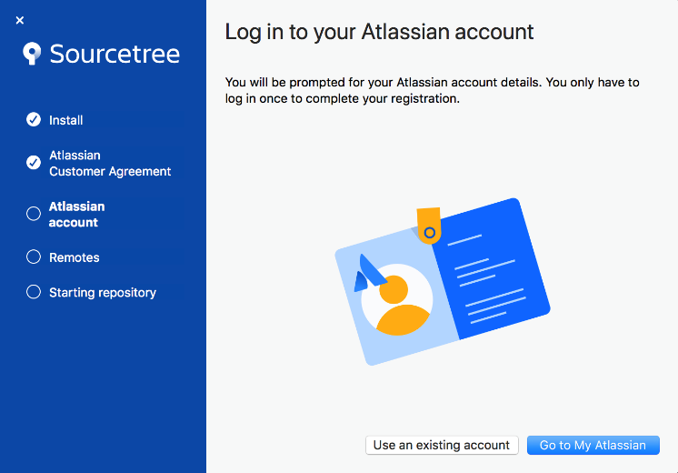

1. If you want to connect to a remote hosting service, use the default options as you enter your Bitbucket or GitHub credentials. If you can't continue without generating an SSH key, select **HTTPS** to continue or see [Set up an SSH key](https://confluence.atlassian.com/x/X4FmKw) for more details about setting up SSH with Sourcetree.

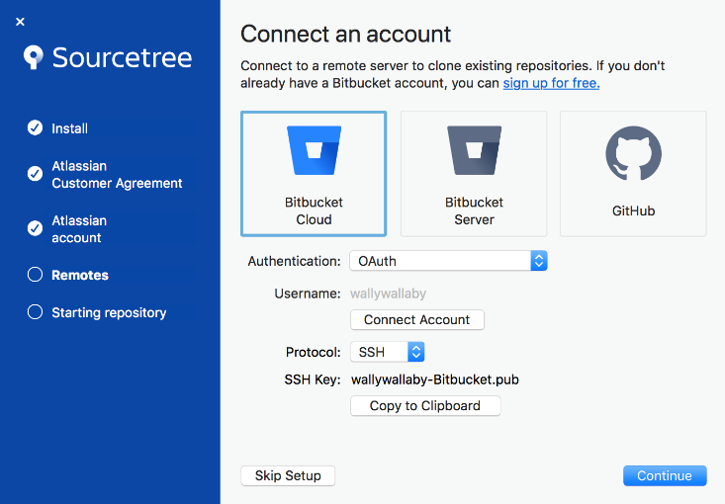

1. Follow the prompts until you're done with the setup. If you aren't ready to clone a repository, click **Skip Setup**.

**GitHub Setup:**

1. Go to <https://github.com/> and sign up and open an account
2. Go to GitHub account and create repository from here.

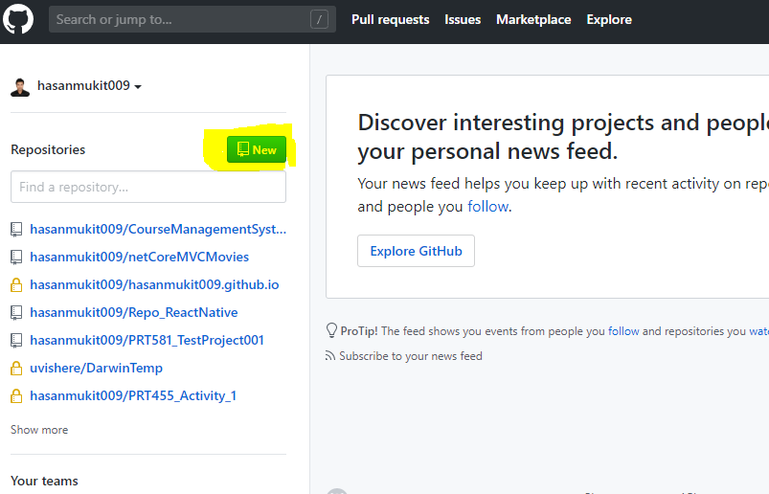

1. Put repository name and create

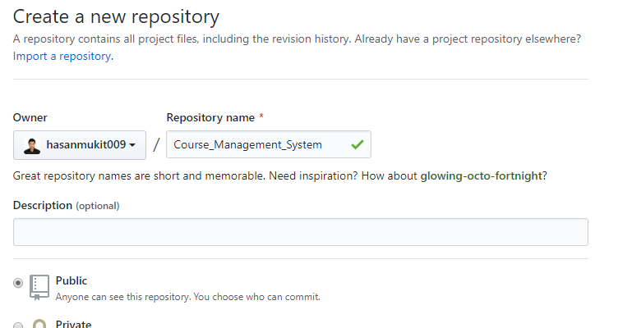

1. Now go to the repository and copy this link

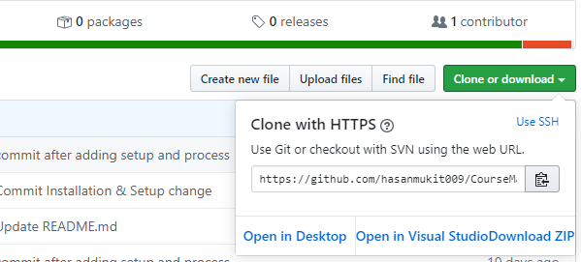

1. Open source tree and click clone

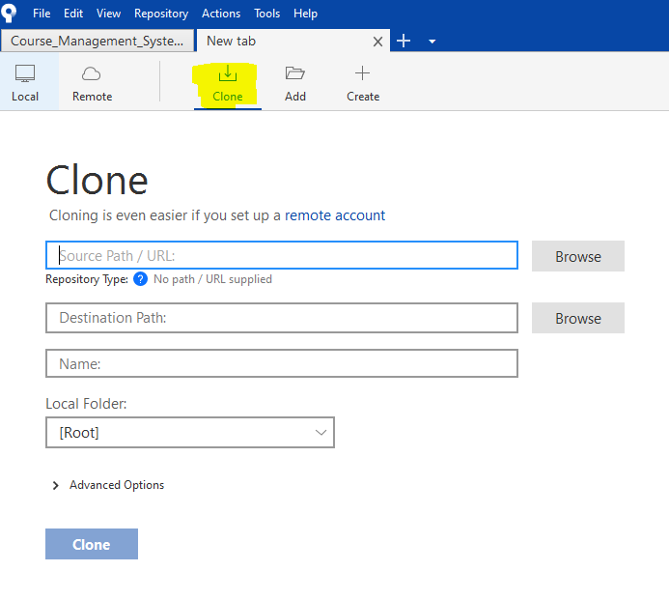

1. In the source path put GitHub copied link and in destination path give local pc folder path

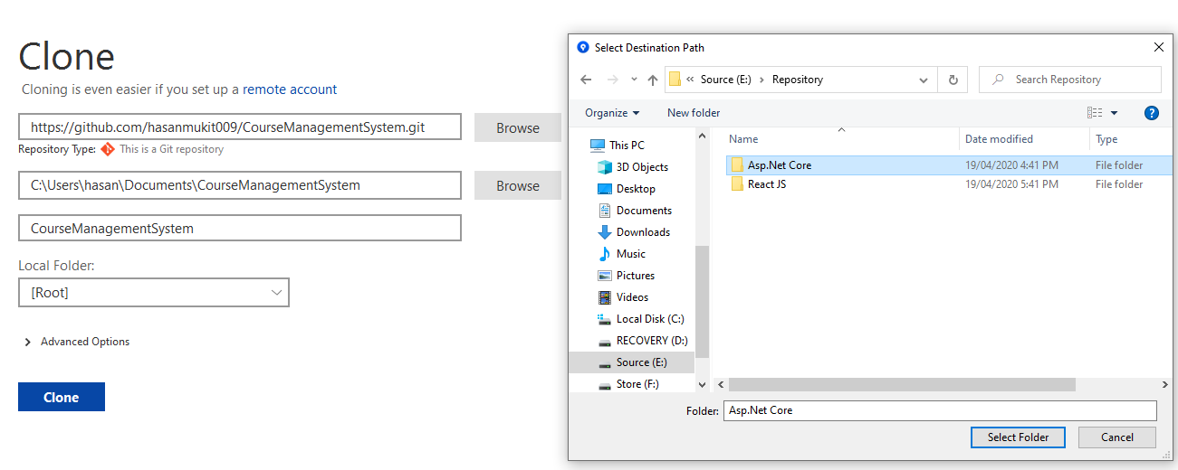

1. Now click clone and your GitHub repository and Local PC folder will be connected.

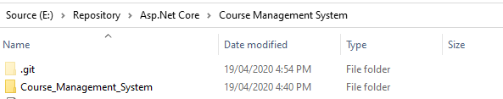

1. Now go to that folder.
2. Create visual studio project here in this folder.
3. **Open visual studio 2019 and click Create a new project**

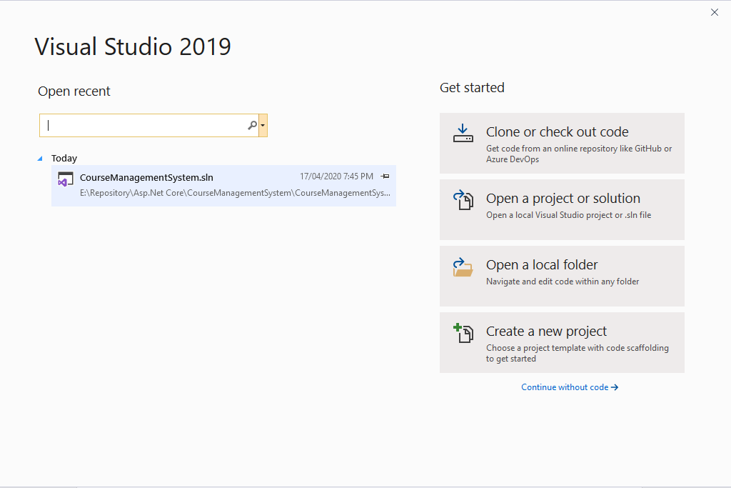

1. **Select Blank solution and click next**

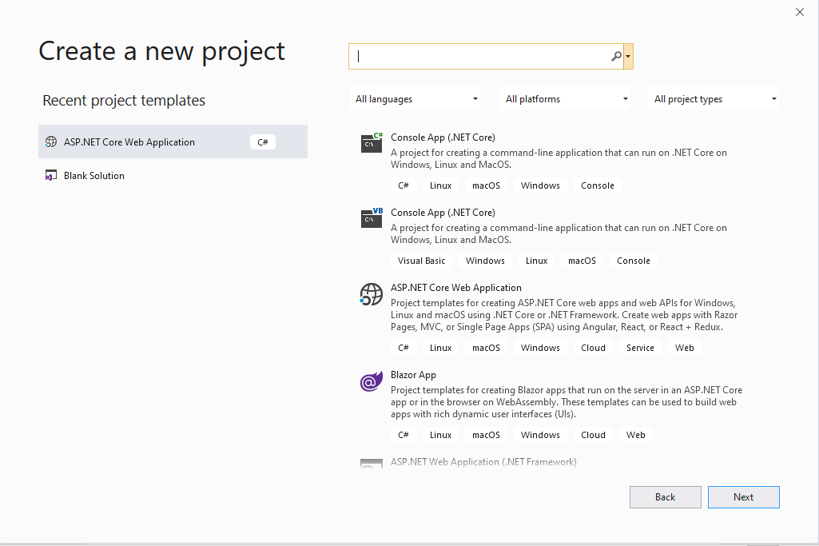

1. **Write the solution name “Course_Management_System” and click create.**

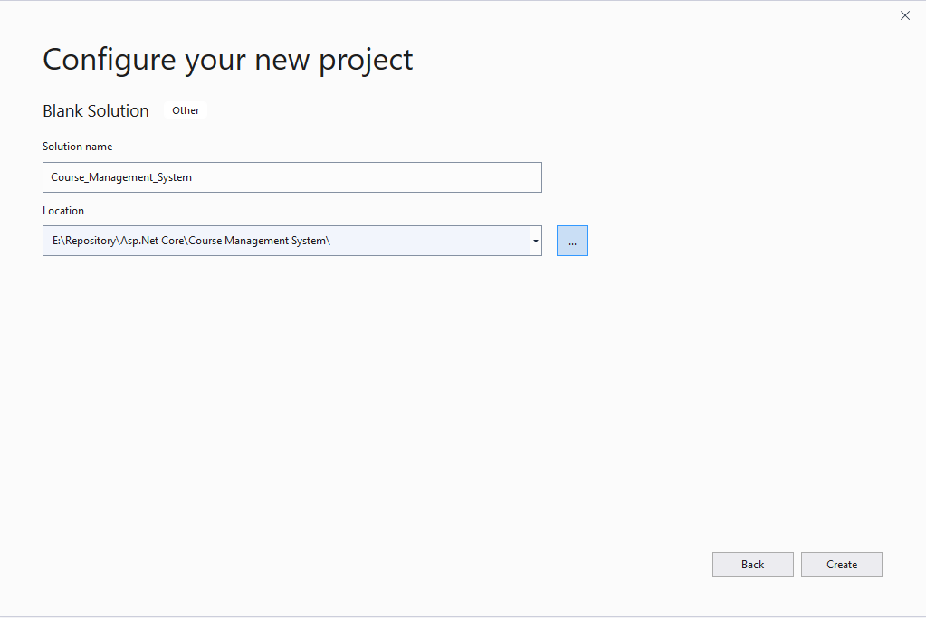

1. **Now solution will be like this.**

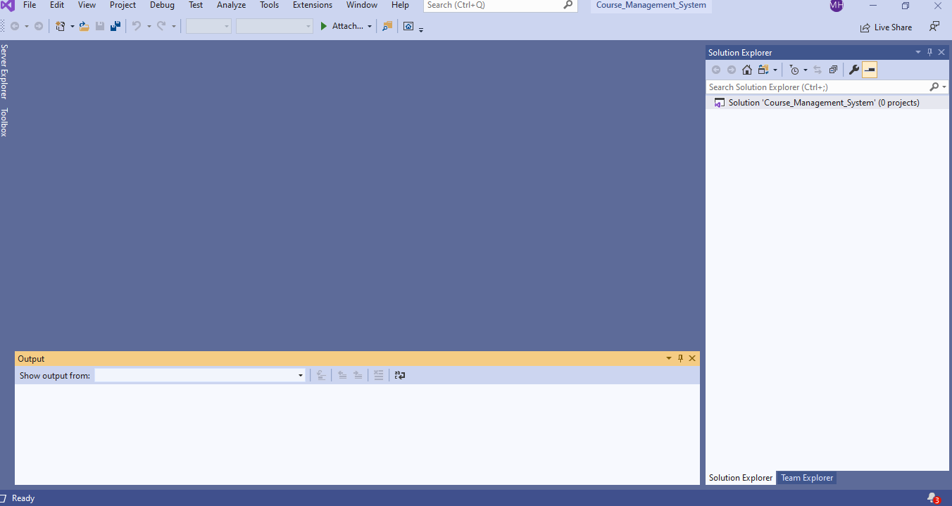

1. **Now right click on the solution and add new project**

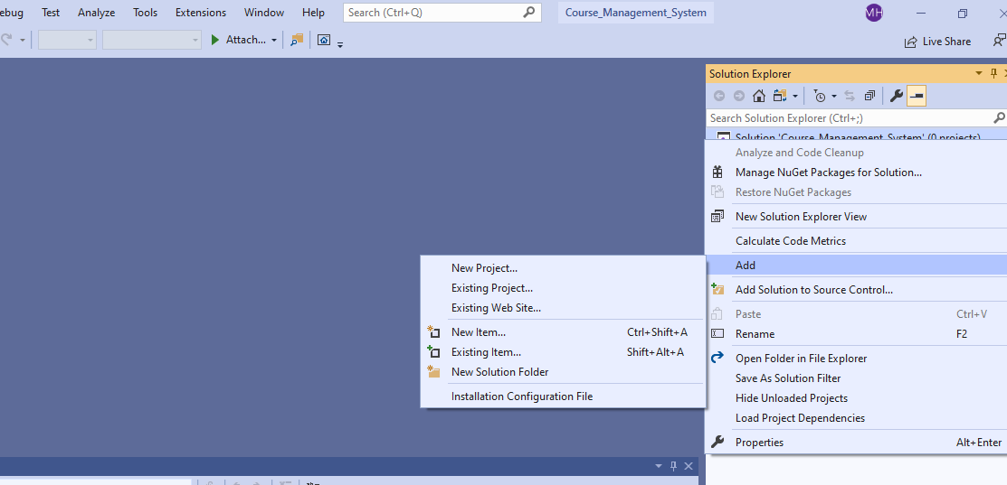

1. **Select ASP.Net core web application and click next.**

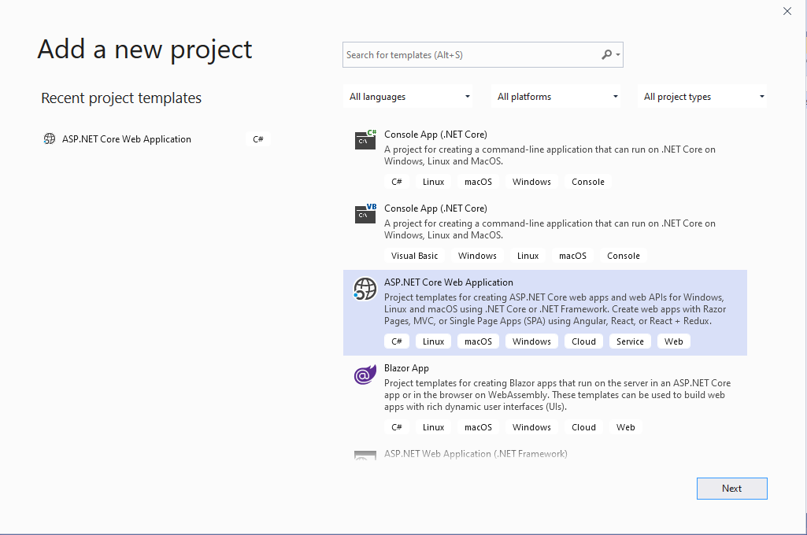

1. **Give the project name and click create.**

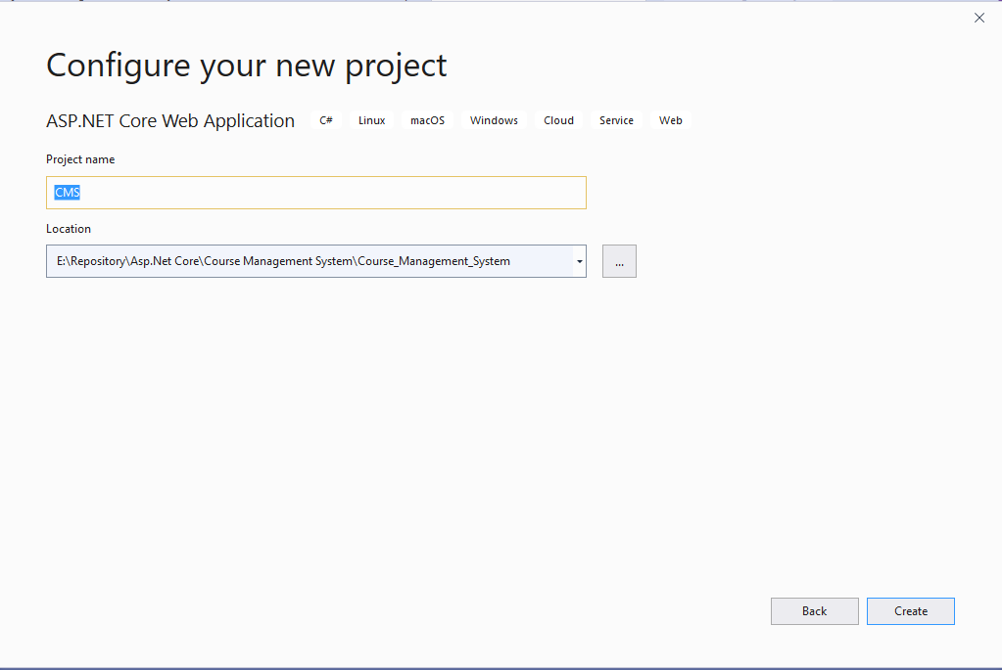

1. **After creating project select these things and click create**

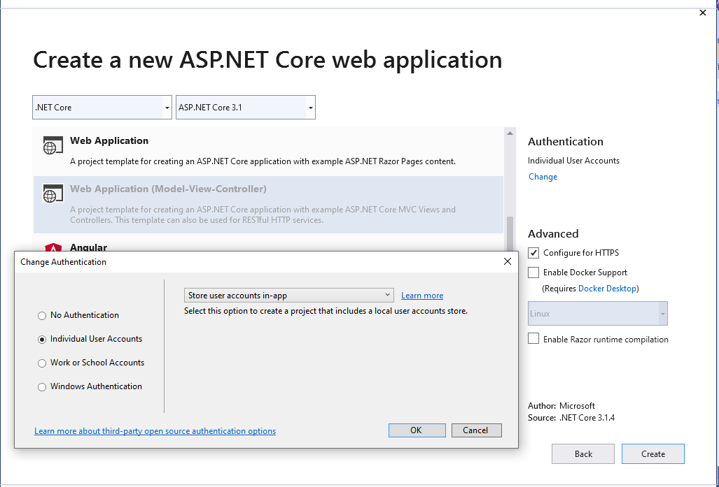

1. **So, this the initial project**

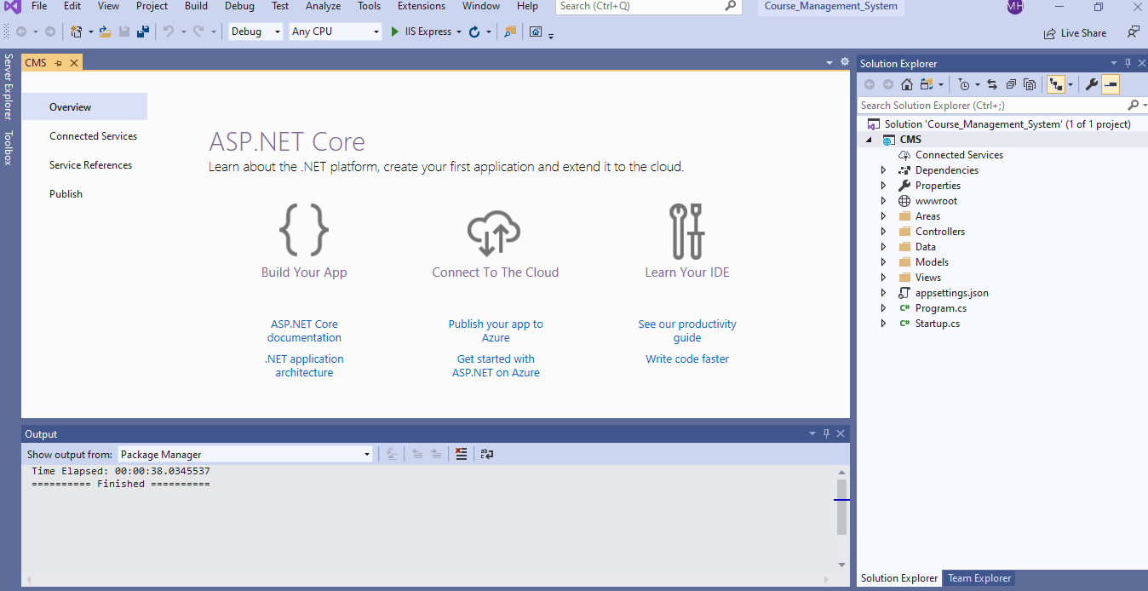

1. **Build the project and Click run**

* **To build a project you need to right click on the solution and click build or rebuild**

**Or you can click here**

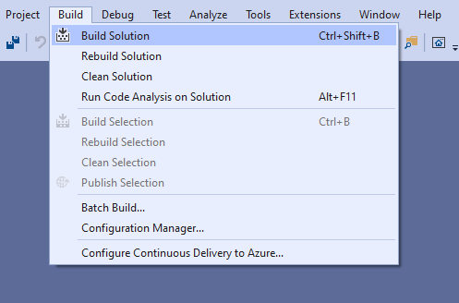

* **To run the project, you need to click here**

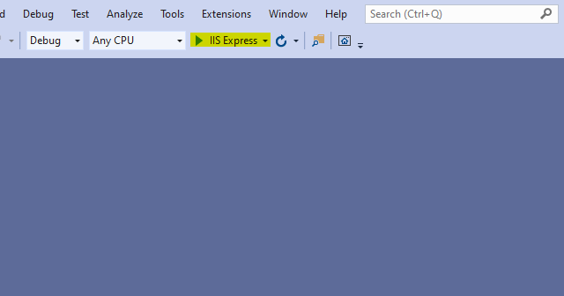

**After run, project will be shown in browser**

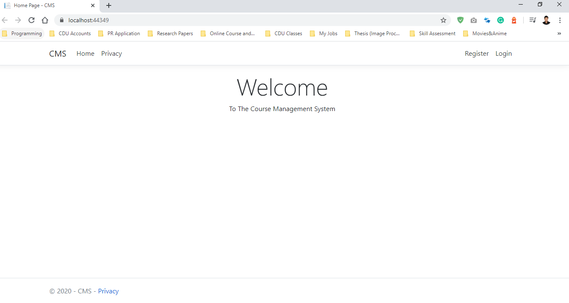

1. Now change the **connection string** here

**Copy the code from this link (**<https://github.com/hasanmukit009/CourseManagementSystem/blob/master/Course_Management_System/CMS/appsettings.json>**)**

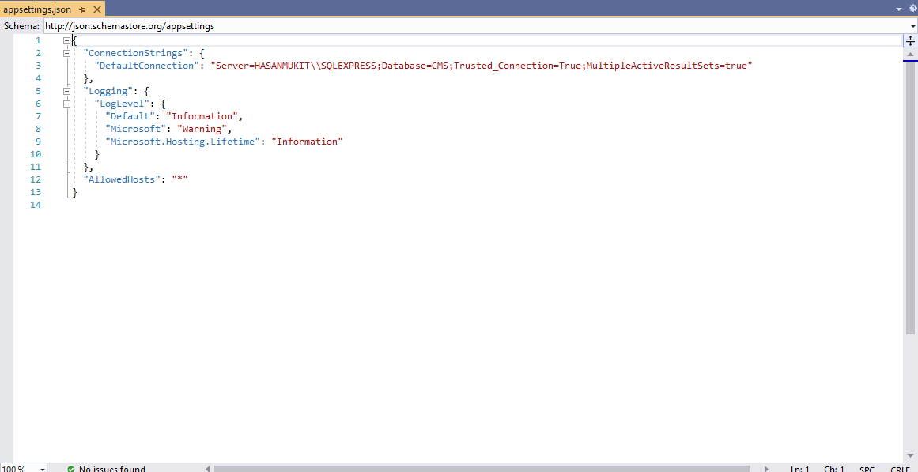

1. Now go to the visual studio and click **Package Manager Console**

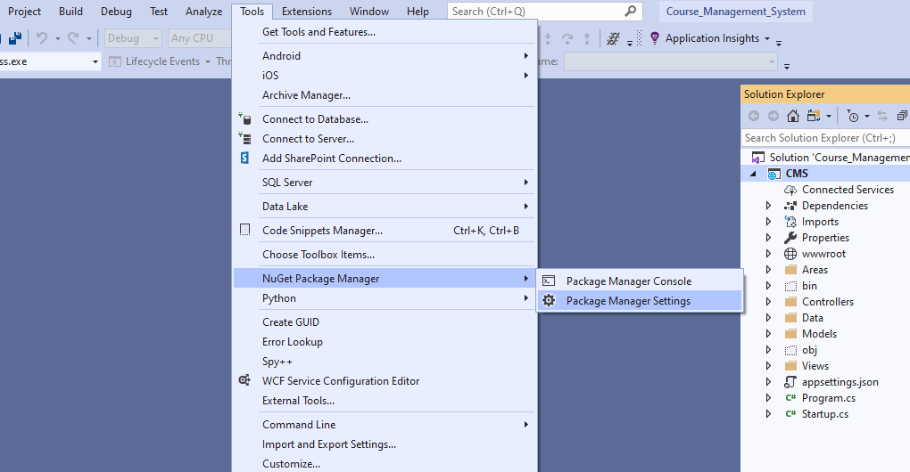

1. **Write “update-database”**

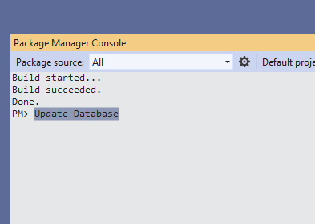

1. **Then database will be updated**

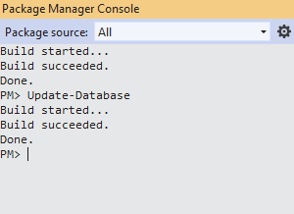

1. When you go to **SQL SERVER MANAGEMENT STUDIO**, you will see the database CMS has been created.

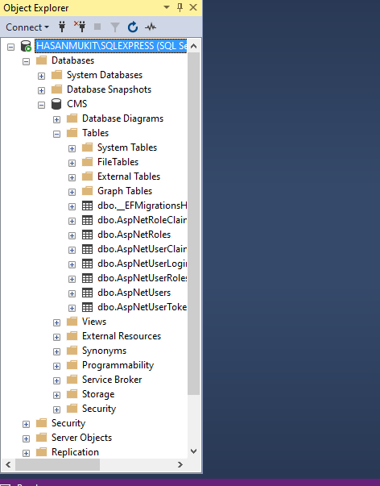

1. **Now click on Register and register page will be open**

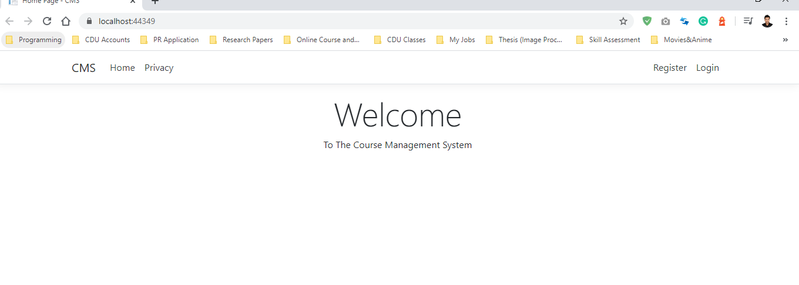

1. **Register page will be like this**

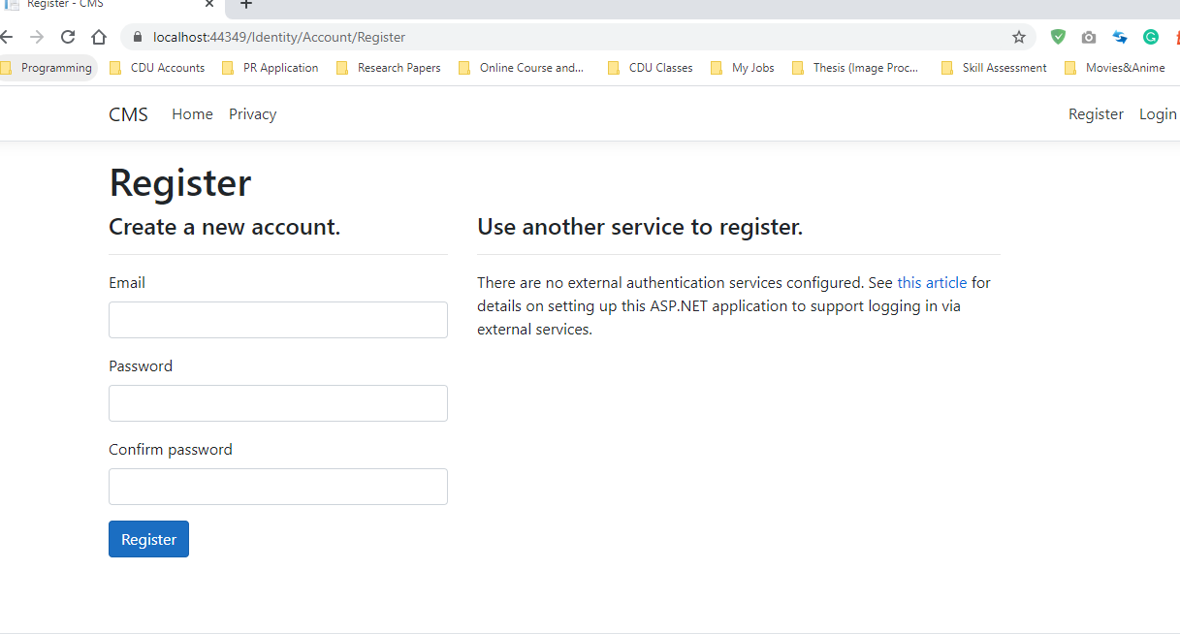

1. **Give all the information and click register and a new user(hasanmukit009@gmail.com) has been created. Now you can login**

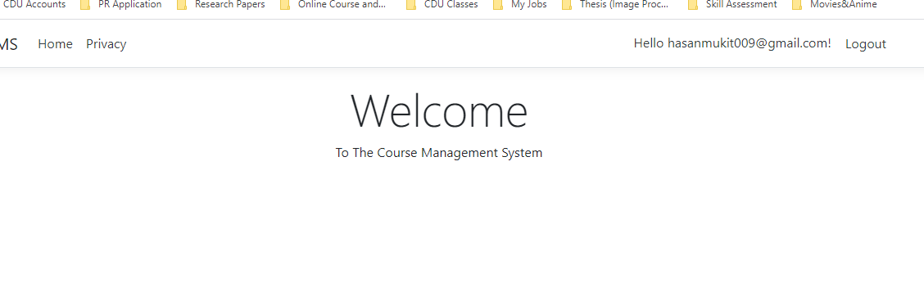

1. **Click log out and then click login**

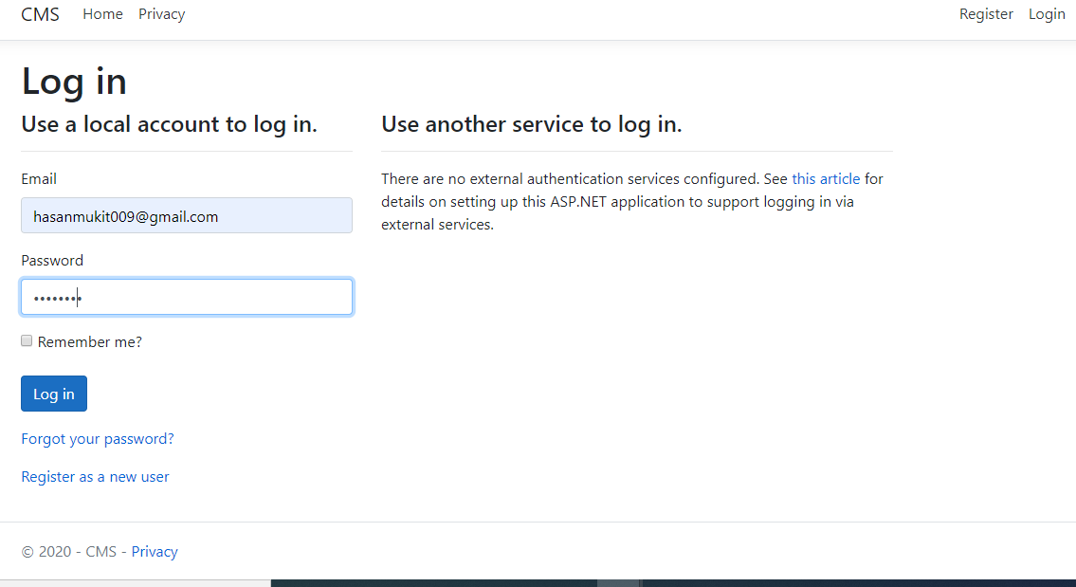

1. **This page will open**

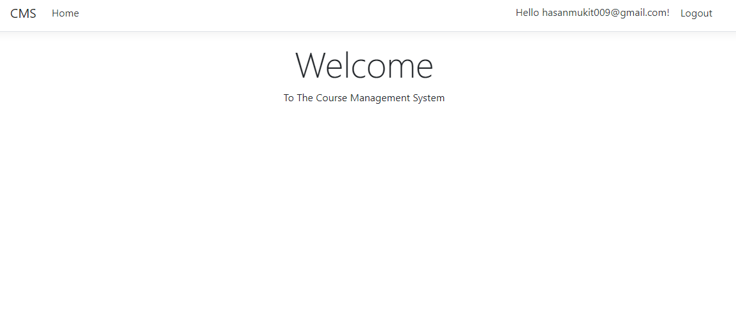

1. **Open layout page (/CMS/Views/Shared/_Layout.cshtml) from project.**

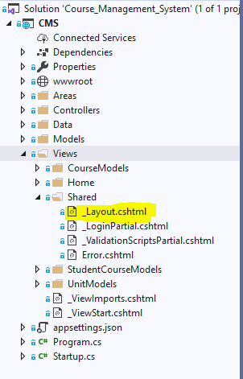

**Copy the code from this link (**<https://github.com/hasanmukit009/CourseManagementSystem/blob/master/Course_Management_System/CMS/Views/Shared/_Layout.cshtml>**)**

**Add this code and run**

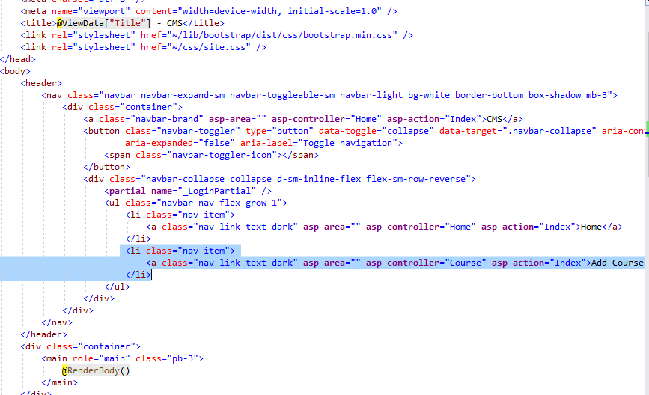

1. **Now click run and this will open**

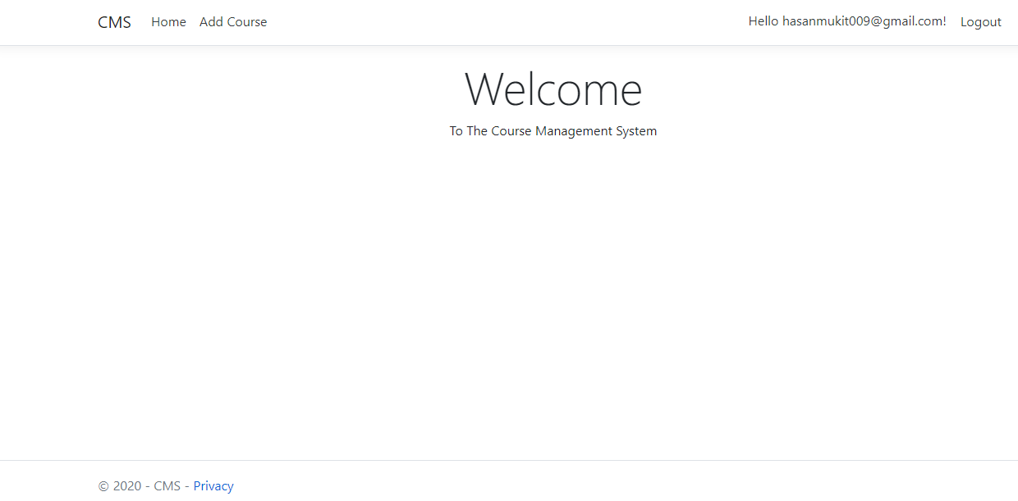

1. Add **CourseModel.cs** class in **Models folder** and click add

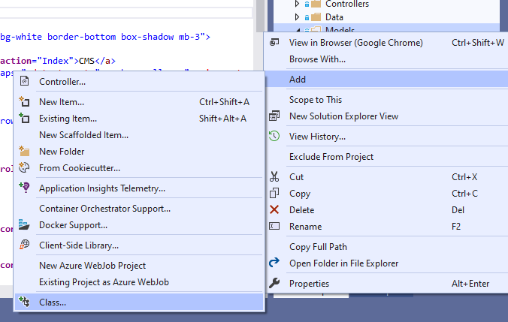

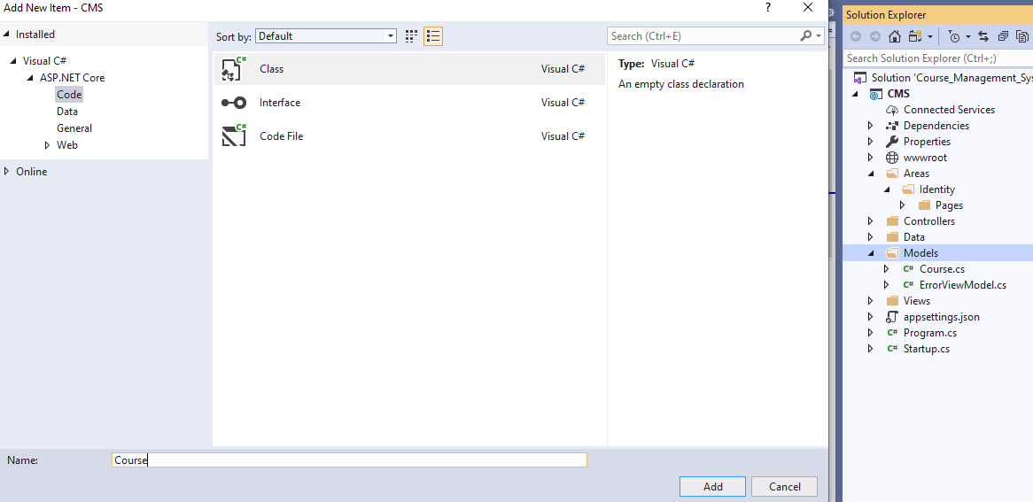

1. Add these codes in **CourseModel.cs** Class

Copy code from this link (<https://github.com/hasanmukit009/CourseManagementSystem/blob/master/Course_Management_System/CMS/Models/CourseModel.cs>)

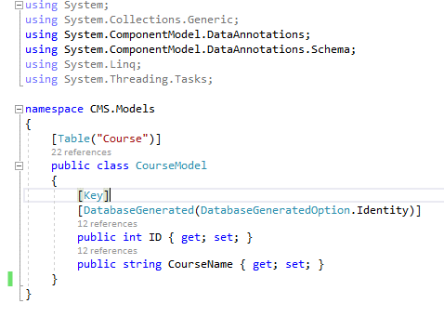

1. Now open Package Manager Console from **(Tools>Nuget Manager>Package Manager console)** and write **“Add-Migration AddCourse”** command

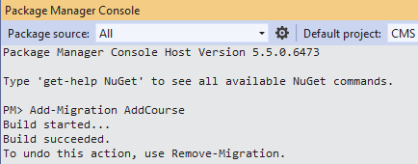

1. Now execute **“Update-Database”** command in Package Manager Console

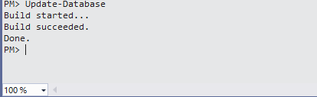

1. Now open **SQL SERVER MANAGEMENT STUDIO** and you will see the new table **“CourseModel”** has been added.

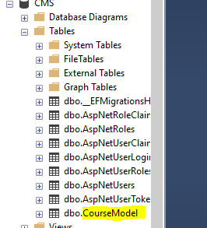

1. Now Add controller in Controller folder

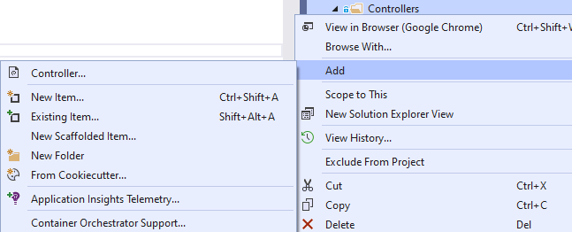

Select this and click add

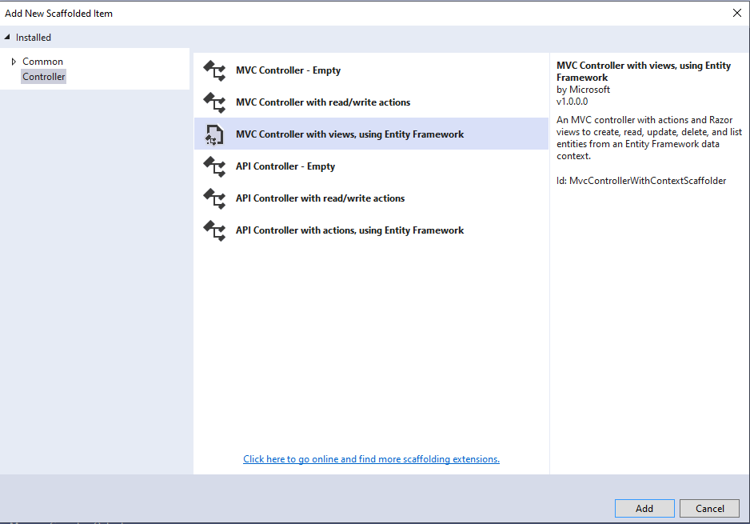

1. **Give all this information and click Add**

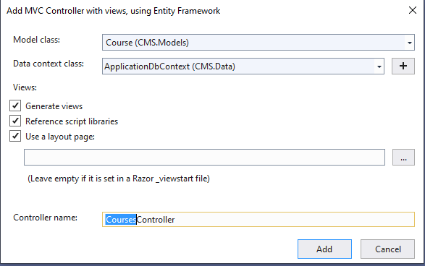

1. **CourseModelsController.cs** controller has been added, and it will be like this

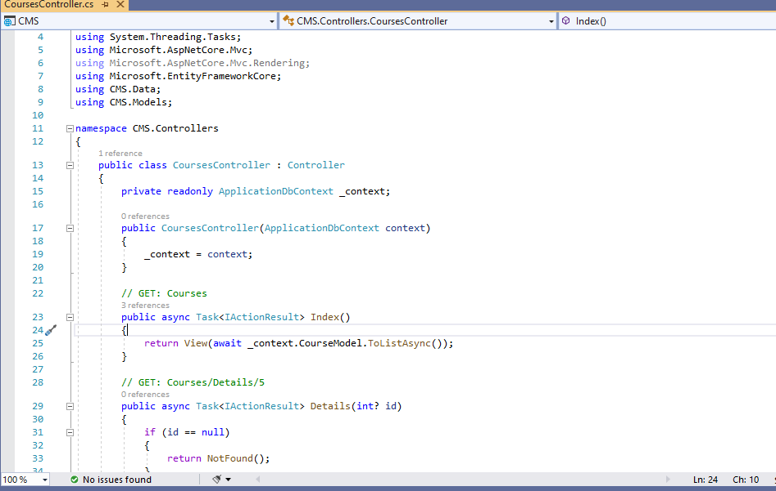

1. **Now run the project and you will see this**

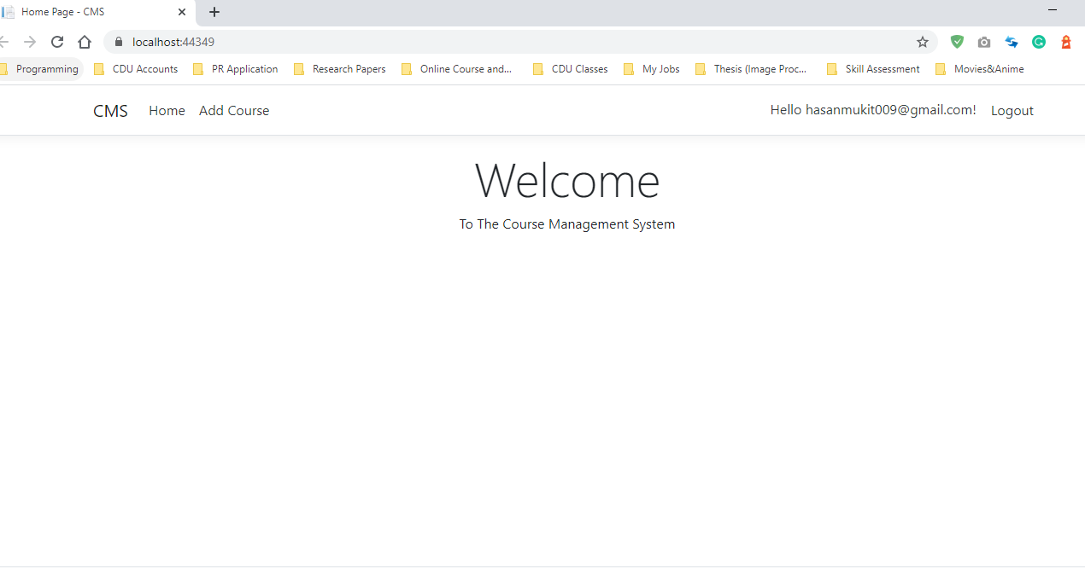

1. When you click Add course it will be shown like this and then click **Create New**

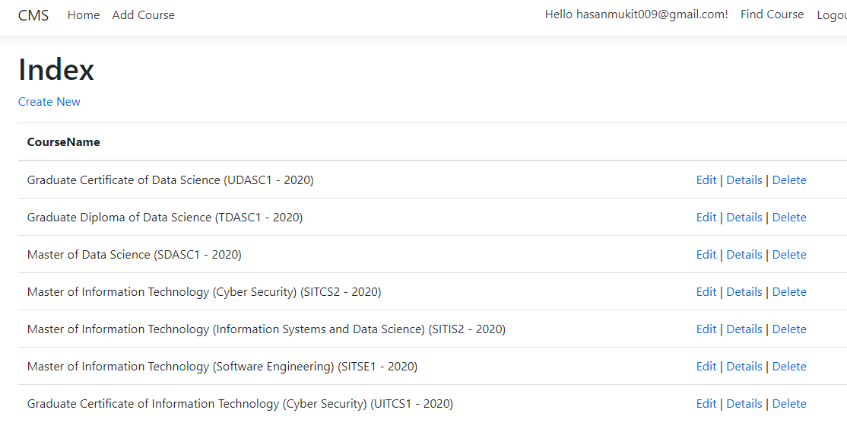

1. This page will open and write Course Name in the text box and click **Create**

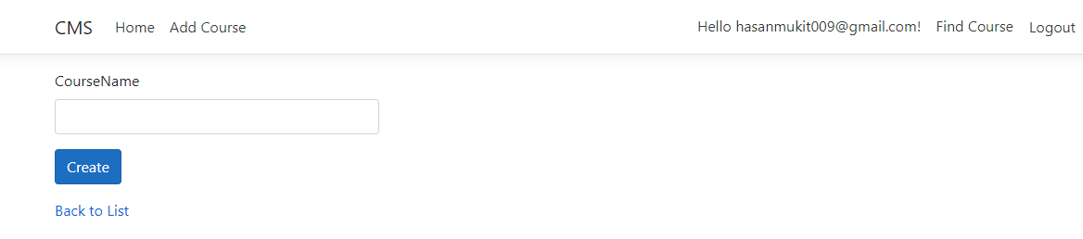

1. New course will be added to the list

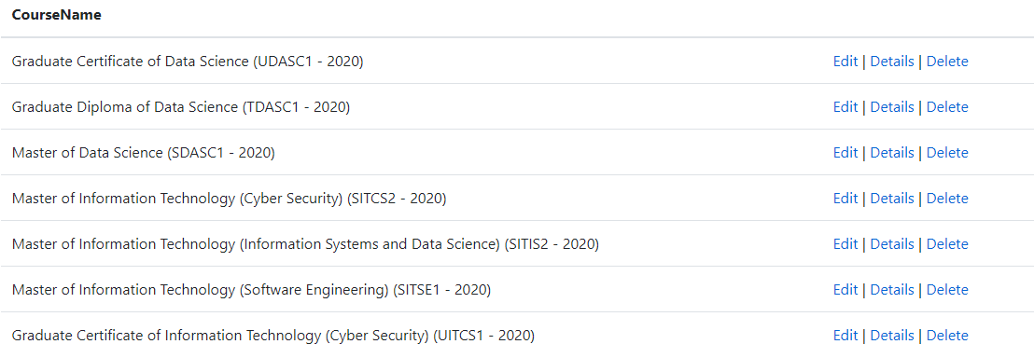

1. You can **Edit** and **Delete** and show **Details** from here
2. Now add this piece of code in **_LoginPartial.cshtml**

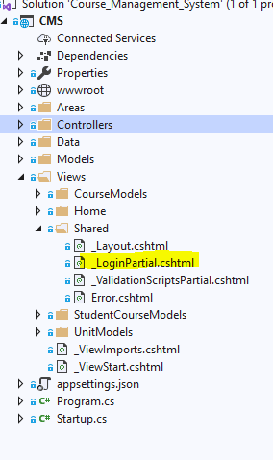

**Copy the code from this link (**<https://github.com/hasanmukit009/CourseManagementSystem/blob/master/Course_Management_System/CMS/Views/Shared/_LoginPartial.cshtml>**)**

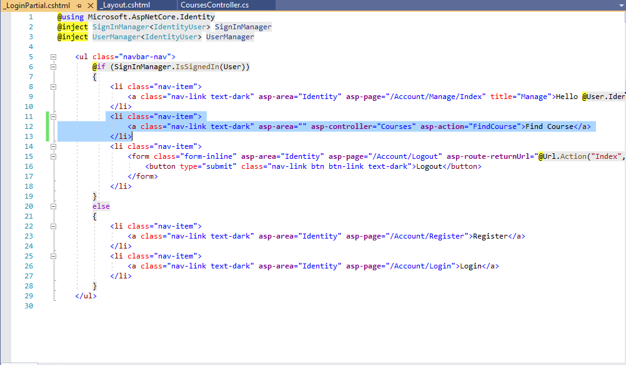

1. **Run the project and it will be like this**

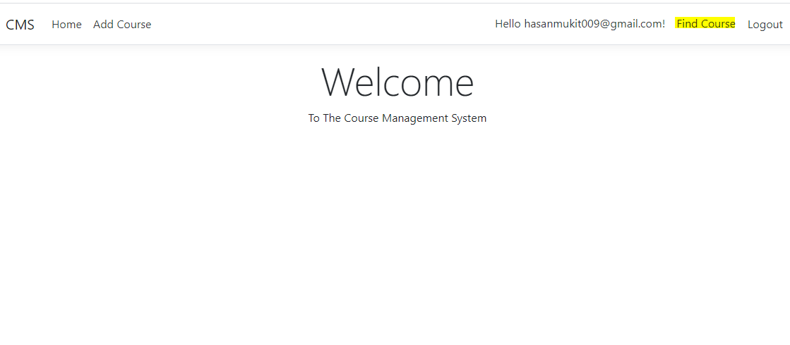

1. Add this code in **CourseModelsController.cs**

**Copy code from this link (**<https://github.com/hasanmukit009/CourseManagementSystem/blob/master/Course_Management_System/CMS/Controllers/CourseModelsController.cs>**)**

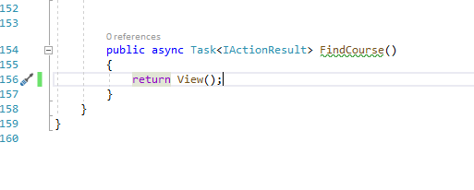

1. Run the Project and click **Find Course** link

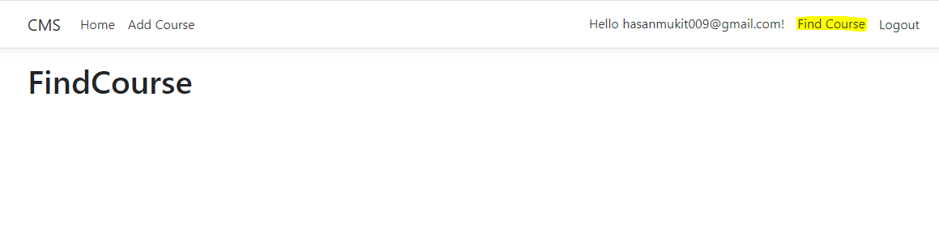

1. Add this code to **_Layout.cshtml**

**Copy code from this link (**<https://github.com/hasanmukit009/CourseManagementSystem/blob/master/Course_Management_System/CMS/Views/Shared/_Layout.cshtml>**)**

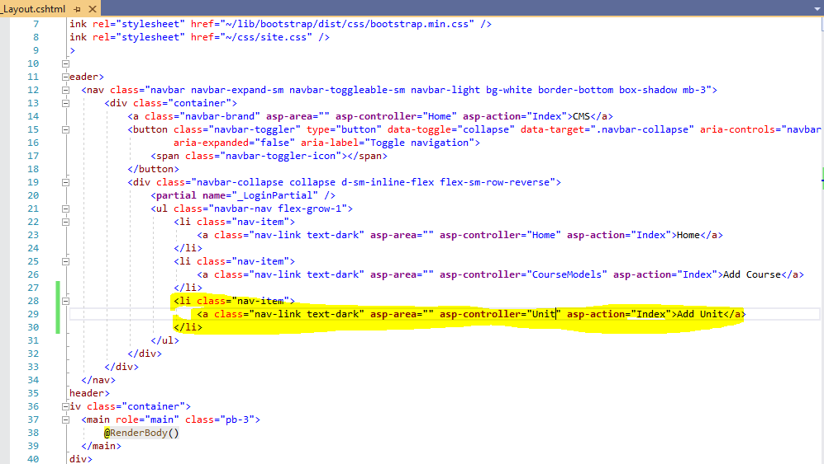

1. Add **UnitModel.cs** to Model folder

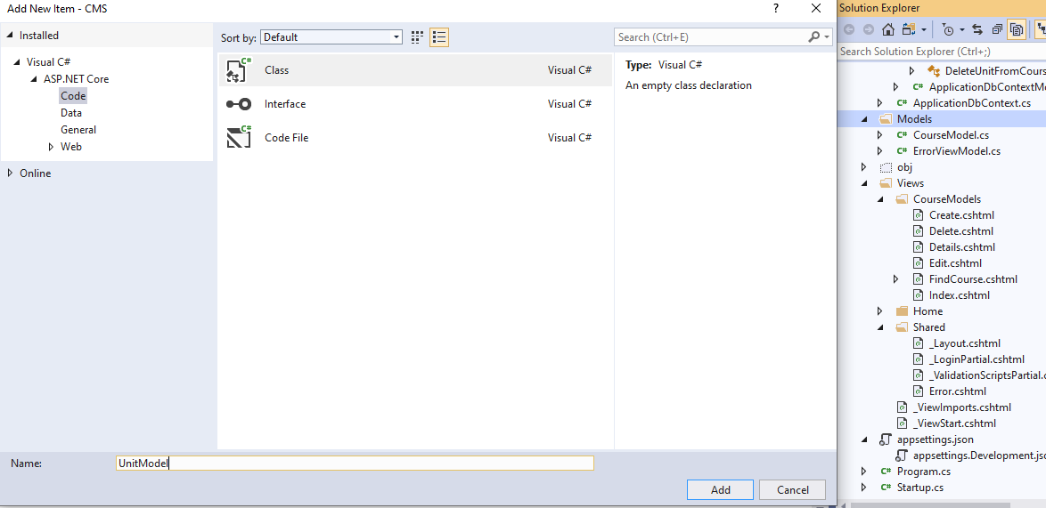

1. Add these codes to **UnitModel.cs**

Copy code from this link (<https://github.com/hasanmukit009/CourseManagementSystem/blob/master/Course_Management_System/CMS/Models/UnitModel.cs>)

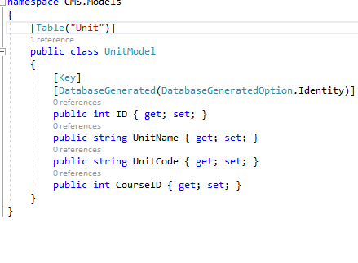

1. Now Run these commands in **Package Manager Console**

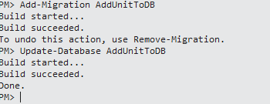

1. Now add **UnitModelsController.cs** to the controller folder

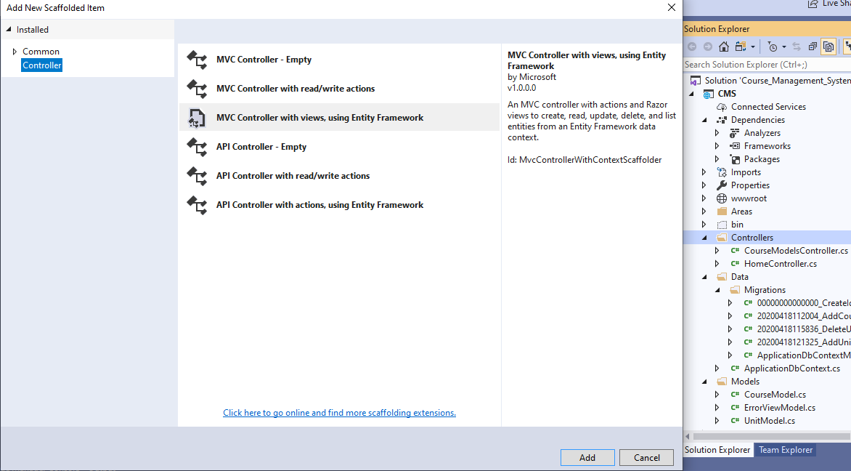

1. After selecting this information click **Add**

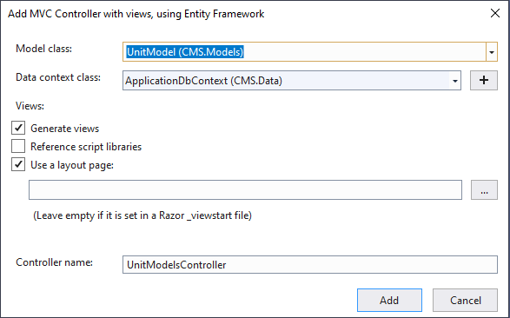

1. UnitModelsController has been added to the controller

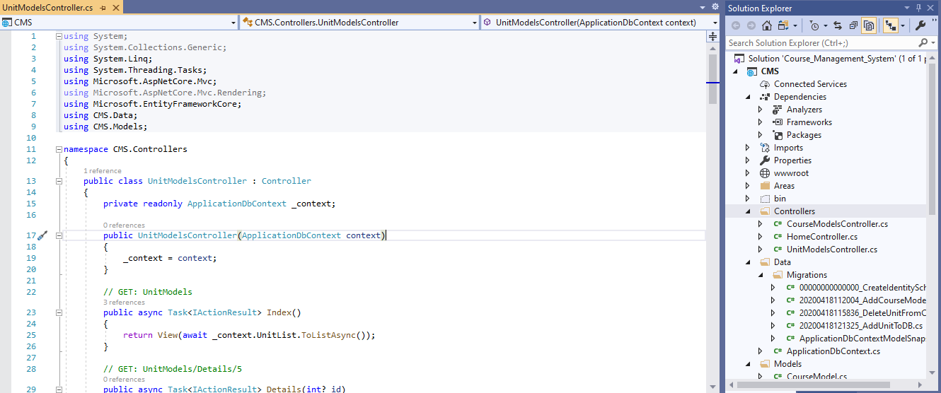

1. Now run project and click **Add Unit**

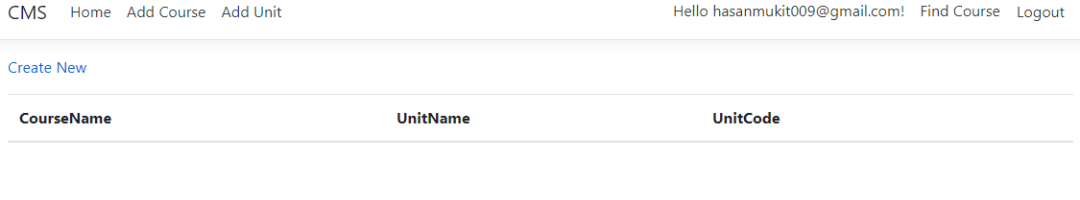

1. Click **Create New** and this page will be opened

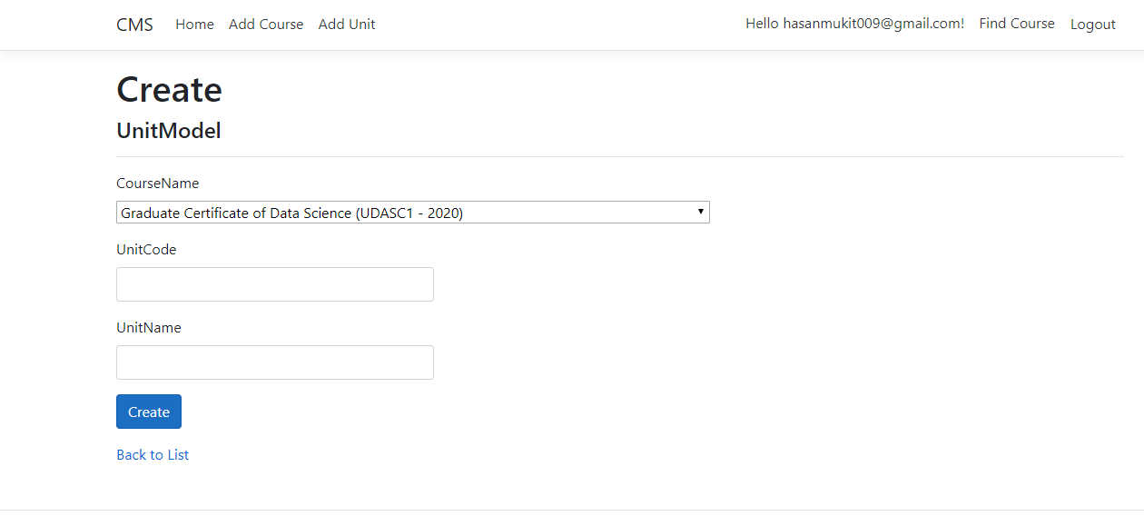

1. Now go to the **UnitModelsController.cs** and add these codes which will create Unit

Copy code from this link and paste in **UnitModelsController.cs** (<https://github.com/hasanmukit009/CourseManagementSystem/blob/master/Course_Management_System/CMS/Controllers/UnitModelsController.cs>)

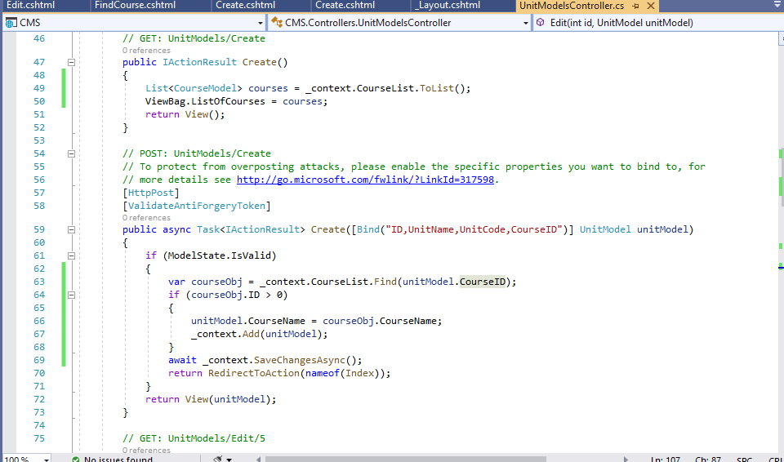

Run the project then **click Add Unit > Click Create New > Fill up the details and click Create**

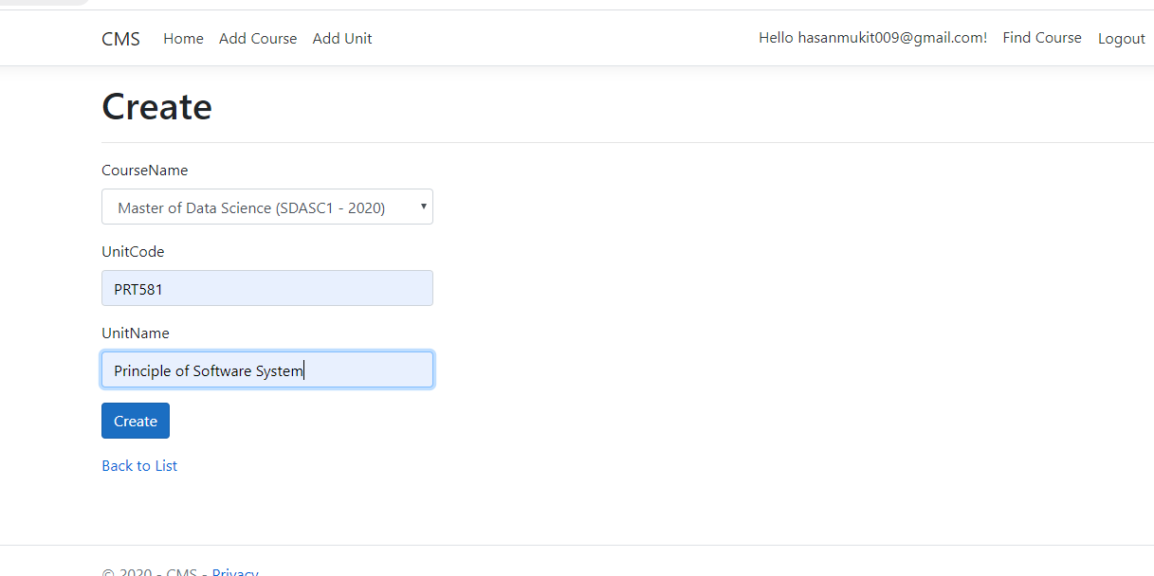

1. Now Click **Create** and new unit will be added.

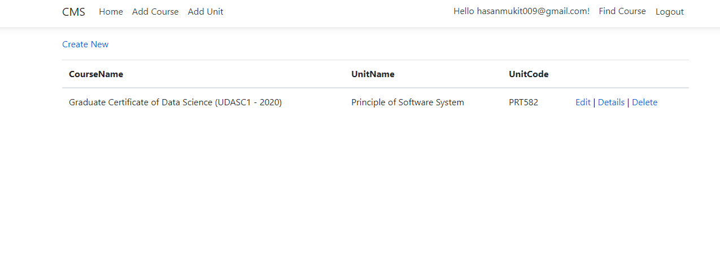

1. It also can be edit, details and delete if you check the code in that **UnitModelController.cs** file
2. Now its time for the Find Course Functionality for students
3. So first create a model: **StudentCourseModel.cs**

**Copy** code from this link **(**<https://github.com/hasanmukit009/CourseManagementSystem/blob/master/Course_Management_System/CMS/Models/StudentCourseModel.cs>**)** and **paste** the code in **StudentCourseModel.cs**

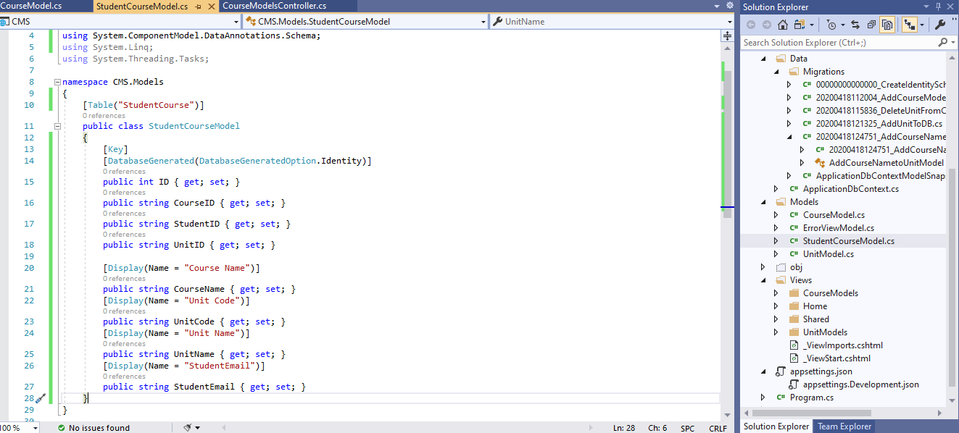

1. Now Run these commands in **Package Manager Console**

* **Add-Migration AddStudentCourseModelToDB**
* **Update-Database AddStudentCourseModelToDB**

1. Now add **StudentCourseModelsController.cs** controller in Controller folder

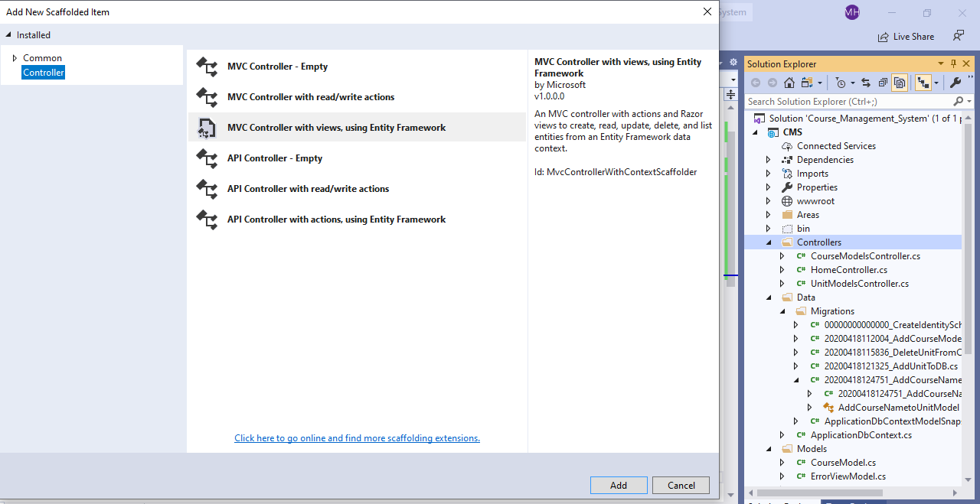

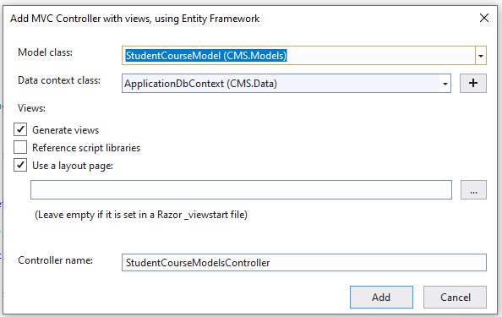

Copy code from this link (<https://github.com/hasanmukit009/CourseManagementSystem/blob/master/Course_Management_System/CMS/Controllers/StudentCourseModelsController.cs>) and paste it to **StudentCourseModelsController.cs**

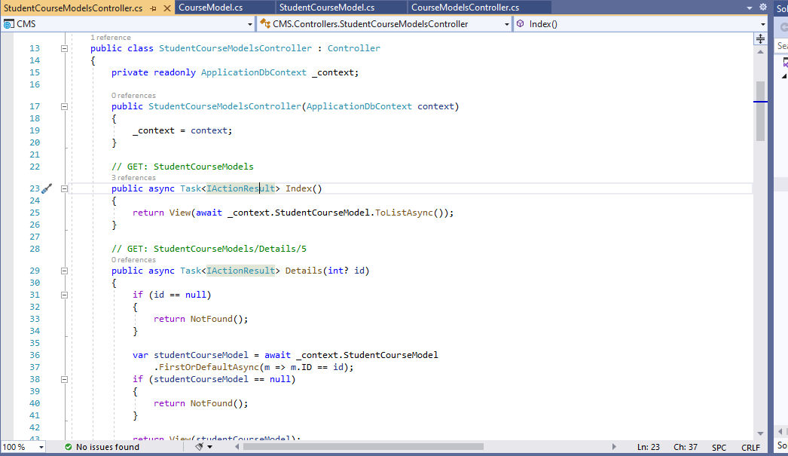

1. Now Add code to give functionality for Add, Edit and Delete and Details. This is the page when you click Find Course

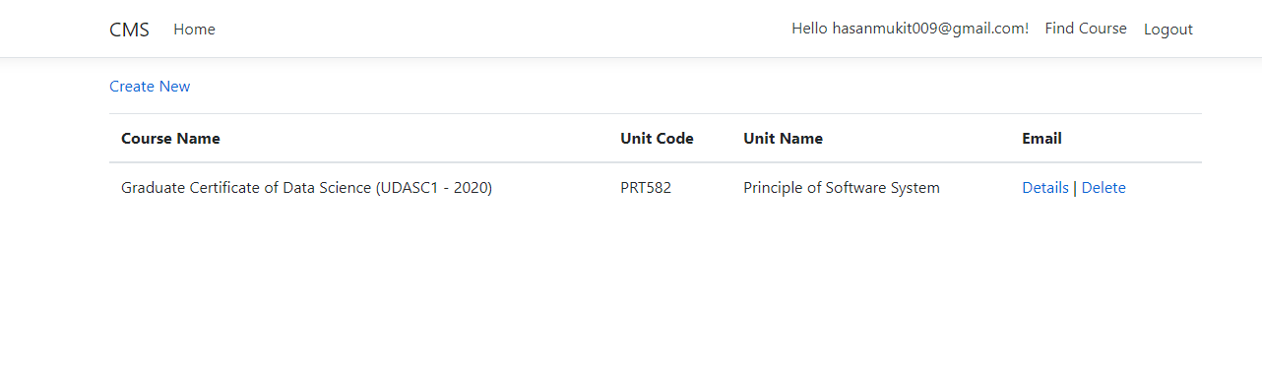

1. Run the project > Login > Click **Find Course** > Select Course Name and Unit Name > Click **Create**

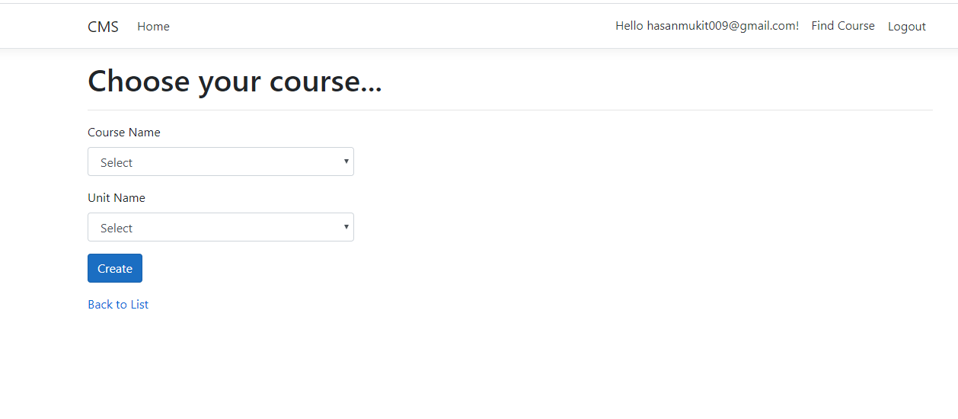

1. New course has been to the user’s account**.**

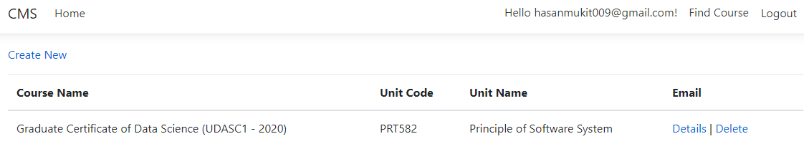

1. Now open Source Tree and you will see like this

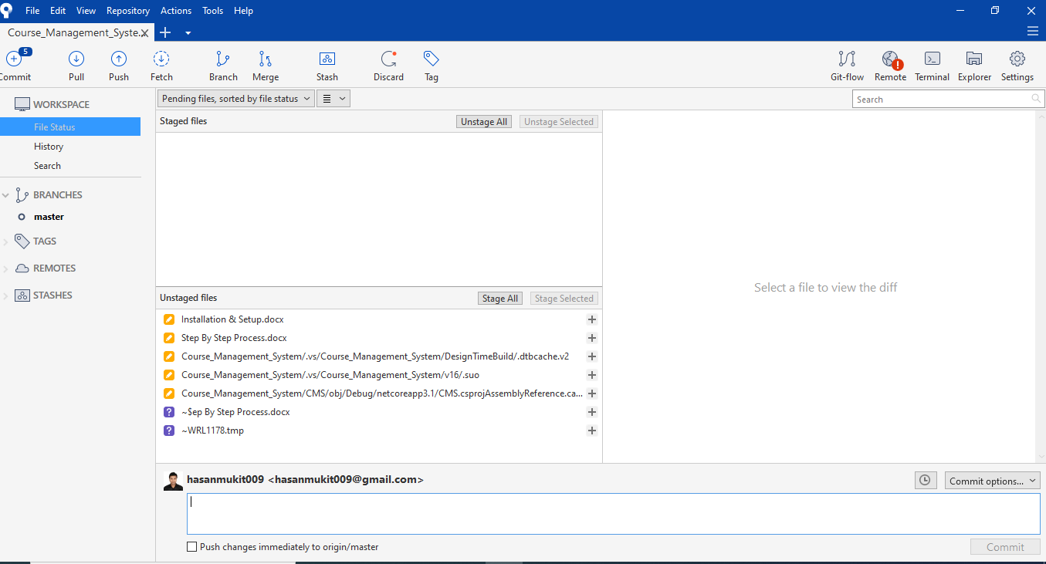

1. Click Stage All